# Bank of England

Inflation Repor t

November 1994

Inflation Report

November 1994

Summary

Recent developments in in(latir›n

.1 Retail prices

1.2 Output prices Expenditure deflators

Other measures of inflation

1.5 Summary

2 Money and interest rates 10

Money and credit aggregates 10

* 1. Interest rates and exchange rates
  2. Summary

*Estimafing market expec'tations of*

*fl. in* /6

Demand and supply 18

Demand

Personal sector 18

Housing 20

Corporate sector 22

Stocks 23

Fiscal developments 23

External trade 24

3.2 pp

Summary 26

*Negative equity*

The labour market 25

Earnings 28

4.2 .trip 29

32

tio 32

###### 4.6 Summary

5 Pricing behaviour

.1 External influences

Commodities

Overseas inflation and import prices

52 Margins 36

5.3 Profitability

Summary 39

*Producer output yrices*

Prospects for inflation 40

* 1. The news 40
  2. The Bank’s medium-term inflation

projection

* 1. Private sector inflation forecasts
  2. The risks to the inflation outlook 43

CnnClMSiOllS 46

not available.

Symbols and conventions

nil or less than half the final digit shown.

Because of rounding, the sum of the separate items may sometimes differ from the total shown.

On the horizontal axes of graphs, larger ticks denote the first observation within the relevant period, eg dnta for the first quarter of the year.

ed by Pa k Commun

BankofEngland 1994

ISBN 1 85730 018 I

ISSNl353-é737

Summary

RPIX inflation—the Government’s target measure—was 2.0% in September, its lowest rate since the series was first published in 19,75. The Bank’s RPIY measure of underlying inflation was 1.2' r, baying fallen by half a percentage point since June. Most other measures of inflation also fell in the three months to September.

.Broa0 money growth has remained subdued. Narrow money growth has continued to .be above its 09r—4% monitoring range. The financial markets responded positively to the increase in official interest rates, suggesting that the credibility of the monetary authorities has been enhanced.

OVer the next two years, output is likely to continue growing at a rate faster than long-run potential, and from .a level closer to potential .than was previously thought. Net external trade has been important in rfiaintairiing growth as consumption has slowed down. Labour.demand has increased. But, although there is some evidence of an increase in skill shortages and settlements may be edging upwards, these have not yet led to an acceleration in nofrinal earnings. At the moment. it is uncertain whether this is because inflation expectations have fallen rapidly enough to counteract these factors, or because earnings growth is about to

.move upwards. The strong increase in .input prices seen earlier in the year has begun to feed through to manufacturing industries’ customers. The rise in output price inflation is consistent with recent suiTey. é*idence from the manufacturing sector, which.

:suggests that larger.increases are in. store.

The outlook.for,lnflation.remains favourable. The economic news

.has led theeBank to! **lower its medium-term** projection. The Bank’s cehtral projection is that .RPDf inflation will bottom out in the eomirig months;.and will rise gradually over the next two years tO around 2!/iR, dt.the top of.the lower half of the target range.

 the Bank’s judgment is

:hat they are not;.at.present, symmetrical.ly distributed around the

central projeetio*. Tbe greatest uncertainty concerns the continuing **difference** between retai1‘and producer price inflation. A8 **Output I:ontiJluTs tt›,grow** above’trend, it becomes more likely tE .tl8% ill tliC Incea of:i5t;crmediate goods will feed through to retail prim. It.will be necessary to monitor these developments



**Chart 1.1**

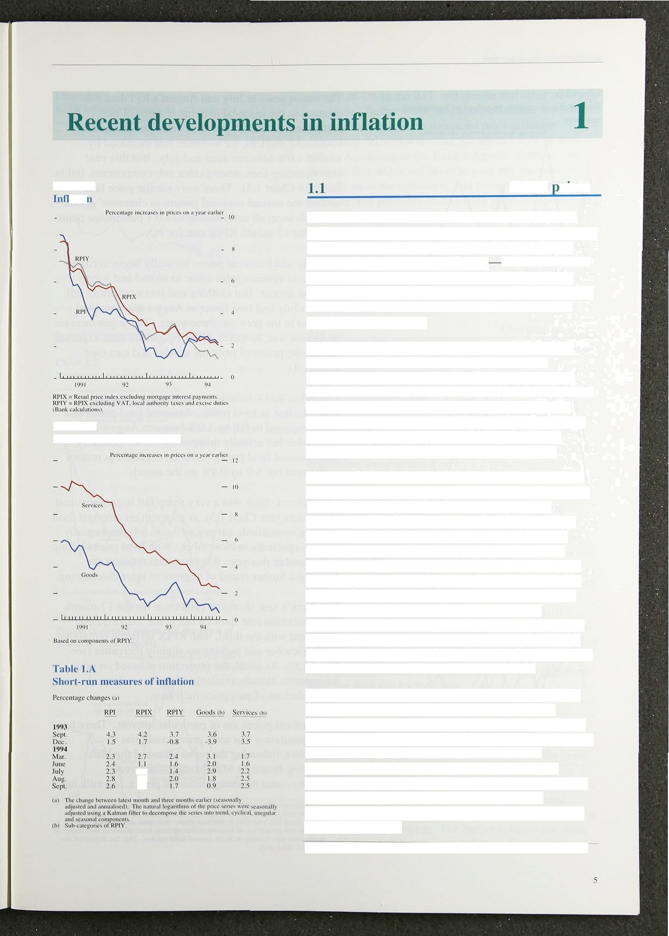

**atio**

Chart 1.2

**Goods and services inflation**

**Retail rices**

Inflation has continued to fall further and faster than expected. The Government’s target inflation measure— the 12-month rise in the retail price index excluding mortgage interest payments (RPIX) fell from 2.4% in June to 2.0% in September, the lowest rate since the index was first published in 1975 (see Chart 1.1). It has remained within the lower half of the Government’s target range of 1%—49r.

Changes in indirect taxes and the Council Tax affect **RPIX** and headline **RPI** inflation. So, to assess underlying inflation, the Bank calculates an index— RPIY—which excludes these taxes. Recent increases in indirect tax rates have masked the very low level of underlying inflation: **RPIY** inflation fell from 1.77r in June to 1.4% in July, increased slightly to 1.5&o in August and then fell again to 1.2% in September.

Headline RPI inflation has followed a similar monthly pattern: 2.6&• in June, its highest level since December 1992, 2.3% in July, 2.4% in August and 2.2% in September. The RPI measure, unlike RPIX or RPIY. includes mortgage interest payments, so changes in mortgage interest rates—or in the rate of mortgage interest tax relief —create a wedge between RPI and **RPIX** inflation. The 0.5 percentage point interest rate rise on 12 September, which took base rates to 5’/•%, will push up headline inflation. By the end of September, the major banks and building societies had increased their mortgage rates by an average of 0.4%: this will add a little over 0.2 percentage points to annual RPI inflation in the 12 months from October.

Annual inflation continues to be lower for goods than for services (Chart 1.2). Goods price inflation in September was 0.5&r, 0.6 percentage points lower than in June. A show-run measure of goods price inflation— the annualized three-month rate-was 0.9&o in September, lower than the 2.07s recorded in June.

Annual service price inflation has continued to fall—to

**2.37n** in September from 2.7% in **June.** But its

shorter-run measure, at 2.5% in September, has picked

up (see Table 1.A).

(lJ '£he rate of mortgage interest tax relief was reduced fmin 25% to 20a in Apnl.



L"hary I.ñ

**hcas‹›naI ini›\’enients in yrices uf** huusehqjd





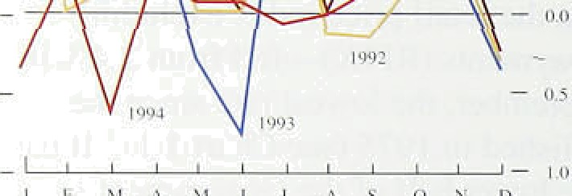



The m;ijor news in.July1añd August’s RPI data was changes.to,the seasonal patterns of some.of the component.series. In previous years, .the prices of houxehol‹i services,’for!i!iistance, had i!n‹ireased:by around .I :0% between June and July., But tliis’year conveyancing.fees„ among„other!sub-,components,!fell }'n July (see Chart 1.3). There were! simi.far price falls. against the norrrial!seisonal pattern in chemists’: goods and insurance, all contributing tfi.a,0. 1 percentage poiht tall in .the 12-month RPIX .rate for July.

Cloth.i.ng hand footwear prices normally begin..to rise .i:n August; as summer.sales.come .to.an enfi'and winter fashions ap.pear. But.clothing anñ footwear prices fel!! more min July and rose .faster i.n August.tiiis .y:ear..than.

.they had in the .previous three.years. The .larger incr.ease in August w,as. .however, offset by grea!ter-than-expected. falls in the prices’ of pârslonal Articles .iiii‹i cars (see

Chart 1 .4).

- ' The fall in RPIX i.nflation in September!.reflected.a

* sharp fiecl!ine in food prices: Seasonal food prices. had

' been projected.to fall by 1.09 between August‹and . September but actually dropped by 3.6.&•. Similarl:y, non-seasonal food prices had been e pected.to.rerriain. unchangecl but1fe!l by 0.49r .on the month..



Last autumn, there was a very sharp! fall. in, non-seasonal food prices (see Chart 1.5)!, as .coriipetition arnon.gst.food retai.lers intensified; :car:prices!')’a!so fell subs’tantially

 and unexpectedly in. November:, With! food prices falling

in Septembet this. year,. it appears.tliat retailed. are

entering a.further rounti!of aggrñssive:pnce ‹discounting..





* I.fJ

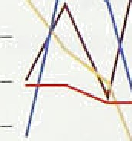- \/6'

* U i'

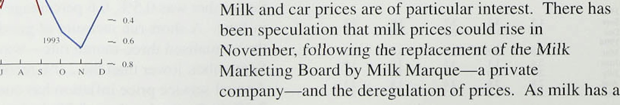- 0.4





6



vehicles and gieaier use of short-term leasing:.de.als.haie increased the 'number of;

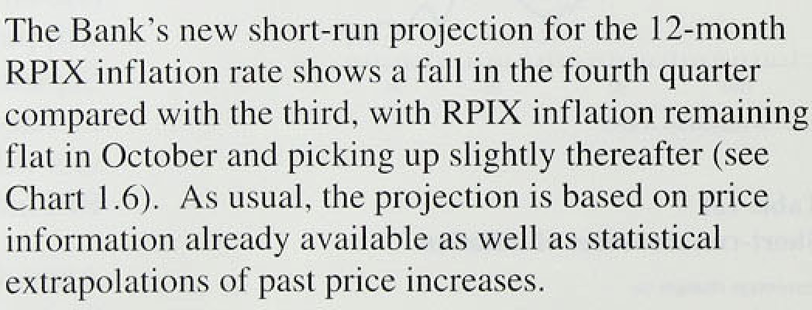nearly'-new cart.eomi*g.on to rite.second-band.inarkei: **Tbia.hâ's:dépreisid** thé





**RPIX Inflation projections 'and outturns**





weight‹of .1.% in the.RPI. and cheese and other milk products a.further 0.7So, any sharp price rise would have a sigñifieant impact on measured price inflation.

Door-.step delivefles account for around 509a of milk sales. !Accordi.ng.to.the B.ank’s .Agents, .if prices rise, firms in.tfiis sector are!likely to pass any increase strai.ght on!to the customer. But competition in food retai:ling will probably lead to milk prices in shops being held. down.

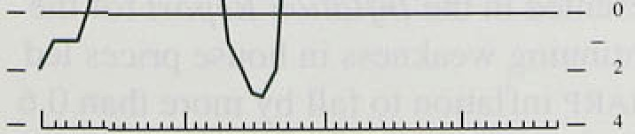

.Car::prices *ore.* usually weak in the fourth quarter.



' Moreover, with new car sales not as .high as expected,

.further downwar‹i pressure on the prices of nearly-new cars is::expected during the next three months.

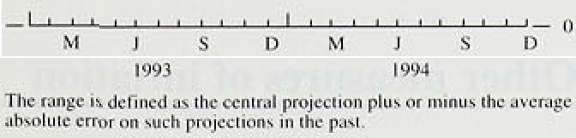 1 2 O t ce

Annual producer output price inflation rose by



0.3 percentage points between June and September, to 2.4%. tExcluding those components most affected by changes in ,excise duties—food, drink, tobacco and petroleum—the annuai rate was 2.19’c in September, an i’ncrease of.0.I percentage points over the .same period (see Chart 1.7). But the annualised three-month measure (excluding.those items) rose by 2.2 percentage points betvieen June and September, to 3.69c.

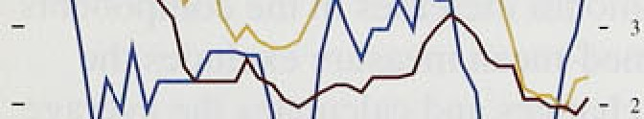Tlie.producer output price. series may be a lagging indicator of ehan.ging inflationary pressure. It takes time for'rñahufacturers.at different stages of the production process to adjust their output prices in response to changes..in costs. The prices of golods sold by one manufacturer lo another in the same seclor are excluded

.from the series. The sterling prices of imported

.tnaiiufactures—which are used both as inputs to the production process and to satisfy final demand—can be a.guide:to prices of.intermediate goods .in the production sec.tor . The annual inflation rate for



’’ i:mporfed:manufactnres increased in the three month.s to tune but: ttien fell .back. in.July:

Tiible ,I..B..repo.rts the: annual infIati.on rates of the price deflators:for!GDP.and the iiiajor expenditure coinponents. ! Ali1ipugh the **GDP** deflator is the most comprehensive !measvre of domestically generated inflation, it is\ less.up-,to-date than.!other indicators and is liable to greater’ revision,.. For!instance,.revisions since the publication of the. August *Inflation Re‘port* liave

7





’l’al›l* 1.D Expenditure deflators



„* );,

cqnsequence): domestic. demand.deflators a1so,fell.:

between 1994..Q 1.land Q2. Howexer: there were.shatp



C’hiii I 1.9



white motive measures of inflation



Charl 1.10

I I,4 R P, ’I“HA RP and RPIY





’RPY



i»9 i 

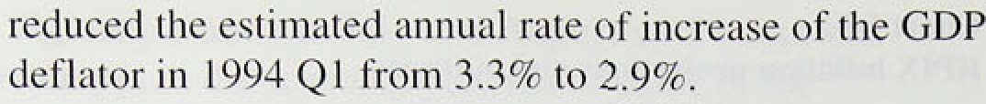

is an alternative measure...of inflatiiin faced by consumers eclined.by 0.4. percentage poi!nts. to .2:5.%;

similar to the rnovernerit.iii R lX inflation over the same period.

L4 ’.Othemf%sursoMn0aton

One-off chan.ges .iri .relative priciis!cari liave .temporary effects on the measure of iriflation obtained fro.iñ!the.

, retail price index. .Unless these.eha Anges.have a.

.longer-run i.mpact, for example .by”âltéring price

, expectations, monetary policy w,ould not normally be

.adjusted to take. account of there:

.Bqth RPIX and:RPIY'rnâasures ex‹i1ude mortgage

.interest !payments „!and'‹so exc'l.ude ,a!iiy measur.e of the i.mpact of changes in. the. cost of owner-occupied housing.. The.housi!ng-adjusted RPI (HA.RP index)! . attempts.to rectify this omission by incorporating a.Bank

.estimate ofi tlie user-cost of housing in the RPIX measure to.proivide an alternative to ther Rfil. This series can a!lso be. adjusted: for indirect taxes, to•produce. an alternative to RPIY the tax and housing-adj.usted retail .price. (THARP) index presentéd in the.lnfl*aiiân Ré!part* for the first.time. The continuing weakness in house pnces.led both HARP and THARP ir1ilatiOn:to .fall by more than.0.6 percentage points between.!June.ahd Septeinber.(see Chart 1.10).

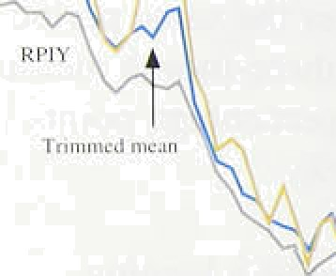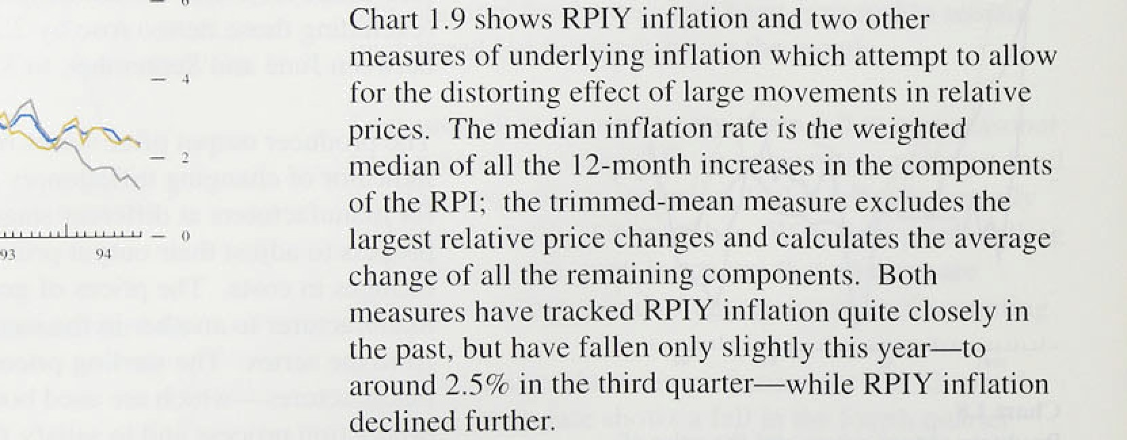

##### ’

 

The TaK 8hñ Price Index (TPI) adjusts the RPI for changes in direct!.taxes: it measures the increase in an individual's gross income.required to maintain the purchasing power of net-of-tax income. April’s income tax and national insurance contribution changes increased the gap between **TPI** and RPI inflation from



0.2 to 0.4 percentage points, and **TPI** inflation .rose to 3.0fip in April. TPI inflation has subsequently declined, to .2,fi9’o in September, but the gap has not narrowed (see Chart 1.11).



-' '- 2.





##### lS S a

RPIX inflation—the Government’s target measure—was 2.0&« in September, its lowest rate since the series was first published in 1975. The Bank's RPIY measure of underlying inflation was 1.2&«. having fallen by half a percentage point *since tune.* Most other *measures of* inflation also fell in the three months to September.

**RPIX** inflation is expected to remain flat in October. but

ithsreafter to pick up sTightty.

9

2. 

Mdne n ed t e ates

’l’iible 2.A

G riiis'th mates of munela i y iiggregittex

The monetary aggregates. coñtinued:!to:diverge ifi the third quarter: Narrow money gro th rpse: arinual MO: growt.h .remained wel.1 above its Ono ,&ñ rrionitori!ng range at 7.39r in fict0ber,. comp e‹i with fi:5.% in:July: But M4’s annual !growth rate declined..to 4.8@r in .



6.4



6.7



7.b

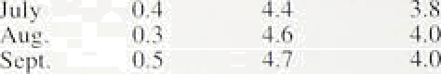

C›.7 7.1

: ’ ’6



September from

’’’

The rrionthh c

s

ri es ihM0"ft:u0u2 ed d'

st

### ' n’' gii:,:

LJ‹iis‹

8‹minhr



I:i i . S iJ iJ u:II i J.

L”hart 2. I

7.|

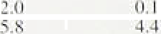

tn eeas dsubstantia by, J:on:o. in!Sep ember,1land their:

.rose by .0.5âo. in O'ctober. So;rñe of:the inointh-to-ñion!ii variation can .be attributed':to. rnovemeq:ts in..bankers.! balances, but fiotes at:d.eciiñ also:acc1élefated to 7ri% in October from 6.5% in July: !'S.ome commentators, looking particularly at the .large positive seasonal. adjustment .in Sep!emb.er, have suggested that iiiadeq.uate seasonal adjustment may..explain recorded narrow money .behaviour .in.!reeent•rriohths: The seasonal lafijustment calculation,. however; Is based on weekl.y observations and inade! .specific.allowance.foF.the boost to the noté circ.ulation from the A.ugust bank hol:day:



l2-n ‹›nth grnn’th rates uf CIO, FI4. Divisia nnd credit



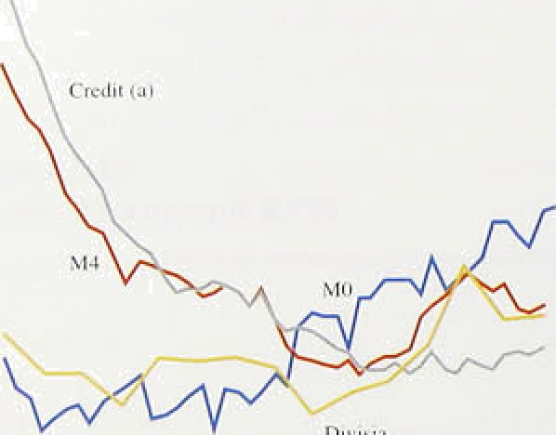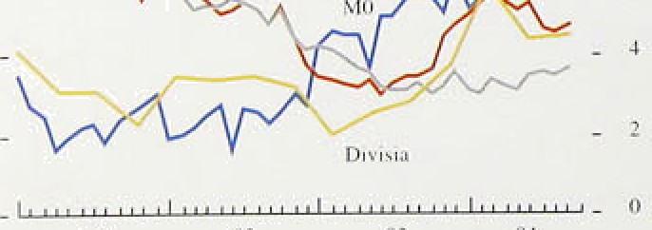

-10

This year the boqst affected'the least weeMy obsemation

in August, rather than t1ie'‹first week in Septeinber.

The August *Inflaiio*n *Repor’t* concluded that narrow money g!rew fa’ster.than predicted from.tlie start of the .’ year.to, July and that.\rrronthly growth of 0.3% to .0.4&c

.durin.g the rest of.the year would.fie coqsistent witli. ñonstañf -i.nf1ation. In: the threé iiionths to Cictober,. monthl.y notes and coin growth avéiraged 0.5.% sl'ightly lower than the average, iiionthly. .rate of 0.6@o In tire first

.hal.f of ihé.;year, but stiil higher than expected. iVith the. i.iiterest rate.effect on‘narrow money growth diniinishing (the!s"eriñslof reductions until ’February.this. year following the United Kingdom*s exit from the ERM should .by now have liad most of their impac;;.land the iiiost receiit rise will as yet. have .had ve ‹1.ittle effectt ), the growth of narrow money remains a cause for ’concern.

(t)



 

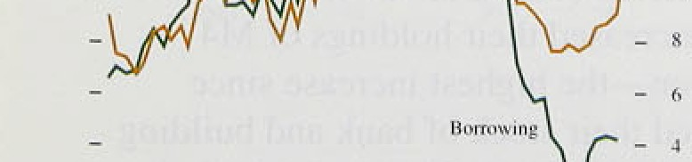

M4,growth weakened further!during the third quarter.

” After reaching a peak of 5.69c in March this year, its

.annua1:rate fell. for two quarters and stood at 4.8% in

.Septeinber. Over the past six months, the underlying monthly growth of M4 appears to have settled around

.0.3%, compared with an average of 0.5&o in the first three months of the year. This slowdown appears to be related to the behaviour of the retail component of M4, which. having increased by an average of £2.1 billion a month in the first quarter, increased by only £1.1 billion a month ifi the past six months.

The main credit counterpart to M bank and building society lending to the private sector—has remained relatively subdued. Lending to the M4 private sector rose.:by 1.1% in the.third quarter, compared with a quarterly average of 0.8% in the first half of the year. Its

.12-month growth rate was 3.7% in September. compared ivith 3.49c in June.

One of the main difficulties in interpreting broad money is the, diversity .of motives for holding M4. Broad money is .held both to finance transactions and as a store of value so that, in principle, a given level of M4 is consistent with a large number of consumption and savings combinations. Recent Bank research suggests that **sectoral** breakdowns of broad money and credit help to disentangle the motives for holding financial balances. By looking at personal and corporate holdings of M4

.separately, it is possible to estimate reasonably stable money-demand functions.

A signi:ficant feature of the most recent recession and recovery has been the balance-sheet restructuring that the private sector has undertaken. This process has

* affected M4, .as members .of the private sector have used
* •• :income that they. might have otherwise held on deposit or spent to repay past debt—reducing the size of their balance sheets.

.Since:the recession, real personal sector net wealth

.initially fell as a proponioh. of income, but has subsequently risen. The initial fall reflected changes in tangible wealtli aad:in particular Changes in house

:priâos. But.between i991.:and 1993, the personal sector al4o reduce‹i:its .gr0ss financial debt as a proportion of

**iittfinl** lms boosfiñg net wealth as a proportion of



lnlliltion Report: Nox'einber 1994

Individuals’ holdings of M4. pickets up fn the third quarter, increasing by 23.3 billion:compared'witb

£1.4 billion in the previoiis:quaiter. Iri the ,three.’months to J.une. individuals appeared to drawl down. their deposits to finance expenditure in .tlie face of the reduced post-tax spending power; this has been reversed in the third quarter.

.B!ank and building society. lending. to households grew by 1.59•. The’ third quarter growth woulfi have been slightly stronp•er had it not been for two;securitisations. After adjusting for loan securitisations.in pfevious quarters, lending for consumption remained broadly unchanged in the third quarter. But within this, banks’ credit card lending, at £0.4 billion, was the highest. recorded increase since 1990 Q4.

Bank and building so1ciety lending .to individuals for house purchase rose by 1,4%, similar to thelgrowth rate. in the second quarter, but below that recordéd !fn.the first three months of the year.. Looking at a wider covemge of financial institutions, however, suggests that net borrowing has ñeen relatively stable over the past year. Other specialist mortgage lenders appear to be:

re-entering the market,.seemingly taking market shâre

from the banks.

Much of the 50 basis-poitlt rise in official interest rates. was passed through to borrowers in higher mortgage rates. The average variable rate for banks.and buil‹iing societies is now 8.l‘%, compared with 7.7% befoJ.thé rise. Building societies in:genera1 increased rateslby. more than banks, thus eliminating the small differential which had existed sinée the turn of the year. Recent analysis. suggests that annual review schemes and fixed rate mortgagesl will have’shiel‹ied over.40&• of borrowers from .the. immediate tmpact of tfielincrease in. rates'.

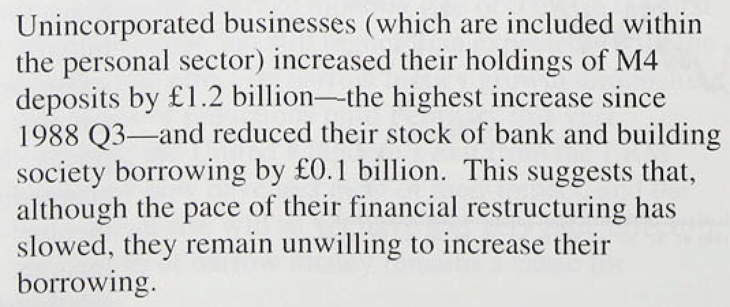

**.Given firins'** access to a wider range of external funds,.it

.is prñb8ble .that the.process of biilance-sheet

12

Mr iirfi- rim / i*irrre if rri/r i

restructuring is nearer to.completion in the corporate sdctor. In the early stages of the current recovery. corporate sector .net debt changed little in proportion to post-.tax profits. Sifice. the .beginning of 1993. however, the .ratio has fal.len. sharply (Chart 2.3). Although both sides of the balance sheet have fallen over this period, the decline in gross debt has been much larger than that of assets.. and 'accounts for most of the decrease in net cielbt. This behaviour is evident in the cumulative net repayment of bank and building society debt by i.ndiistria:I and commercial companies (ICCs), in the region of £7..0 bil.li.on since the start of 1993. Bank fi.nance appears to have been replaced by a. combination of net capi.tal issues, which totalled £1fi.O billion in 1993 and 210.0 billion in the first three quarters of 1994, and retained earnings. which have increased steadily us a proportion of G.DP troin I 0% in 1993 Q l to 14°/r in

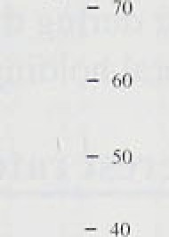

l’9 4 Q2.

For the sect›nd consecutive quarter. ICCs increased their holdings of .M4 by only 0.2%, compared with 3.7Ur in the fi.rst three months of this .year and a quarterly average of 2.1.'Te in. 1993. ICCS have nOw repaid borrowing from banks. and building societies in each of the last seven quarters (Chart 2..4). However, at £0.I bill itin, the viilue of debt repayment i.n. the three months to September wus fiot as .high as the. previous six quarters. During the period,..ICCs.’ sterling .capital issues were lower—the morith.ly average in Q3, at fi0.8 billion, was well below the monthly average of £1.3 billii›n iii the for st sis



months of 1994. The weakness of companies’ extei iial

.financing, however. does not necessari.ly indicate that

..ICCs ai’e .liquidity consti’ained. In particular. .data on cetaineci. eat nings, ,available only to the second quarter. i/nfiic/até corñp‹inies’ internally generated funds remain

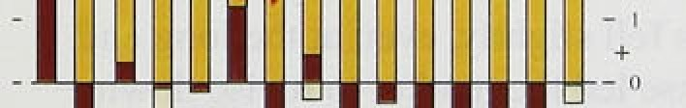,strong. The latest CBI Quarterly Survey rcported that companies do fiot anticipate their capital expenditure ovei°the,next 12 months to.be constrained by an inability to raise extei’nal finance.



previ.ous!:fotir quakers.. This fall. is consistent with recent

.aeti!vi.ty in the finaficia'1.marke.ts. In particular, the M4

. pri.vate sector purchased:f5.4 .billion of gilts in the



Average of.£3:7 bi!l.1.ion i:h the first hal.f of the year. OFIs borrofed £1:.9 billion i.n 1994 Q3. The!increase:

.was Jargely accouritéd:for by borrowing .by securities dealers.

lnl]iititiii Report: November l 9*M

Chart 2.0

**I mplicd forward inHation rates**

The Bank’s index of .Di.visia:!money’(1')..{•ose by"l..1.% in tire thir‹i quarter; compared witli a revised:groytii.of 0.1% in the previous quaner: Oiran..ant ual. bñsis, the .

, , aggregate index increased str.g1itly fo:4.Str. 'This. growtli was largely explai.ned by, personal.sector‹activity



* personal.sector Divisia increased:by I.4%,. whereas corporate sector Divisia grew by on!y 0.25 , The: differing behaviourduri!n.g.the quarter cart largely be explai.ned by sectoral.holdings of:M4 ileposits.

#### t2h2e

lute e t

nd ex h e te

' Since the August *Report,* official interest rates in a number of countries have changed. In the United. Kingdom. short-term interest rates were1 increased by 50 basis points on 12 September in tire light of eoneem



‹ that inflation around two years ahead would otherwise be above the lower hal.f of the. government’s 1: N&» target range. The Federal.Reserve.raised the ‹discount.. rate (the rate charged to depository institutions when they borrow from their district Federal Reserve banks).

„ and target federal funds rate (the rate which banks charge each other on overnight balances) by 50 basis points on 16 August, to 4% and 4.75% respectively, .the fifth increase this year. Italy ,an‹i Sweden also raised .rates in! August, and Australia raised its official.!money-market

**Implied l’‹›r•'tirt4 numinal interest rates**





14

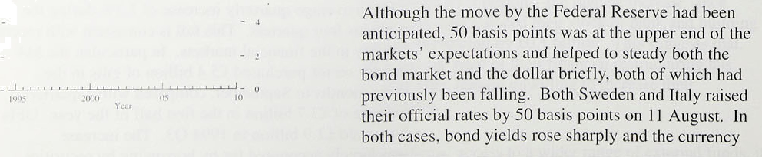

interest rates in. August and.again in October.

The financial.!markets reacted positively. to .the UE!rate rise. Ster1i!ng 1strengthene1d.by about I.% against.the.

Deutsche Mark and 0.7.&1.against the US dollar:on .the day,.anfi sterling’s effective index moved.from 78.6 to 79.1, helped also by a slight improv.ement in thé dollâr. In .the .gilt-edgefi.market,..medium and!1ong-‹rated stocks both rallied on the day,.as the!iiiove was interpreted as a signal of the. authorities.’ anti-iiiflationâiy itite t.

Index-linked prices fell sligi tly,. even:at:the long end.. The nominal rate rise fled!t1ie market to revise. down expectations of future.inflation (Chart.2,3): In ihe money markets, interest rates rose! at al.I maturities. up to 12 mo.nths. ..At longer maturities, implied foiw d rates fell (Chart 2.6). .

”Table 2:B.

**Financial markét:devélopmentsi**

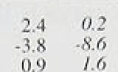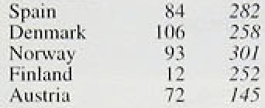



**Table 2.C**



**Sterling exchange rates**

’’ weakened,. wi.th the!Swedish .kroiia and the.lira each fallifig on the. day. In .contrast, !the 0.75 per centage-point increase. in Australiari short-term interest .rates in August añd tfie .further move o.f one e point in October were. ivelcorñe‹i by the bond and foreign exchafige markets against a background of fiscal consolidation and low inflation:. and the Austral!ian dollar appreciated by 0.7fio against the US1 dollar on both days following the respective. moves.

Table 2.B summarises developments in international financial markets during the period since the August *Iii{lation Rey‹›rt* and over the past year. Yields in nearly



.all the major bond markets have. risen further since the end of July,. In contrast to previous experience this year’, howév,er, the increase ifi UK bond yields was smaller than in a number .of countries elsewhere. Char 2.7 shows that al.though implied bond market volatilities tel I sharpl y in .October below the levels seen for most of the year—they .still remain significantly above their

start-of-year levels.

The cun end structure of short-stei’l iiig ftitui es pi ices

.suggests that markets. expect a further’ i.ncrease in interest rates before the. year’.s end. Three-month money rates at 26 October stood at 6.69r for December contracts, risings

, to 7.N.tr and .8.1°/o by March and 4une 1995 respectively.

Beyond that, implied for ward rates suggest that

short-term interest rates are expected to reach a peak at just over 9Tr around 1.597 (See Chart 2.6).

Sterling’s cffectivel index (ER I) has appi‘eciated by 2.47r since. the timel of the last fir/›r rr, compai‘ed with a fall of 3.8âc in..ihe ‹dollar index and a slight appi‘eciation of 0:9fie. in the DM effective exchange rate (see Table 2.C). The UK fr.adr-weighted .world interest rate differential increased further over the period since the August *Inflatioñ Rep‹!›rt,* wi.th UK rates increasing by more .than

;th‹i world average: (Chart 2.8). For three-month interest rates the ‹dififetential is currentl.y around .50 basis points, compared with 20 basis. pfifnts at the time of the previous. *Rep.on.* The differential for 12-month rates has widened !fiirther'and currently starids, at 1 13 basis points (2fi October) compared. with.65. basis points. at 27 July. B.oth US; and .German eurocurrency market rates have increased. over ,the’period.. with three-month rates at

e‹it'ivel , co!n paaarreed wwiith 4.7*/r and 4:9% at.the end of July,







Stcr1iitg CRM 80.9 8 I .9 79;0 78.6 ., '8 .

Deutsche /d»rk 2.ST 2.59 2.49 2:41 2':W,

The ri’se in the.U'K-world .interest rate d:ifferen1!i.al implies .that;”if.the exchange rate.:is assurried to move to bring a:bou/t uncovered’.i!nteres:t parity—=.soithat.the

l nl4iiliou kcpi›rt: Non:eiuhcr 19 J4

’Estliriating **inarket** expectatitins **of inflation**

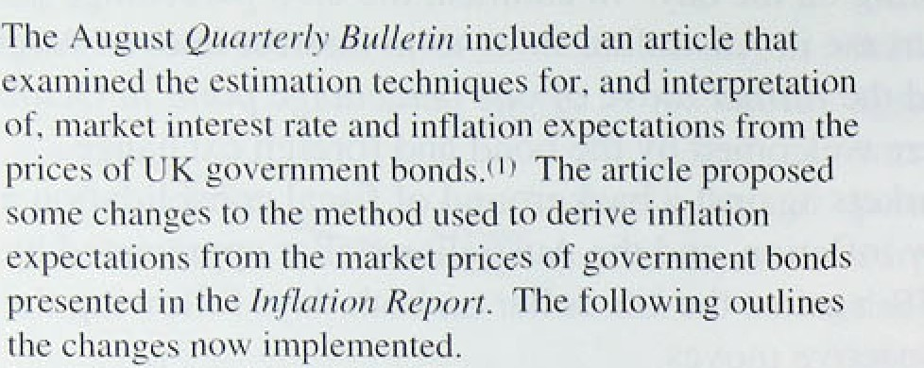.estiinaiion **.procedure.** Callañle bonds **can be. redeemed.by**

.the Btink at a range of different dates rather than a single. fixed date:. Analysis of these bonds..suggests' thnti;heir

. prices an subject to. a number.of bond specific effects which iueons'that'.their inclusion in.1hg estirriation of the forward curve' is'likely to léad fo distortions. ’

°Thé,chart below illustrates iiñplied forward iniiation raf9

:éurves for the previoius!!Banli.inetho.d,.:the new Svensson method and, for comp'arison,!an,approach suggested bj? McCiilloch'(also.described in .the: August'article): .The differencé.s:..betwe.en:..the!yarious.'est:imates demonstrate the' sensiti.yity„,of.the results,to changes of.techn quo.

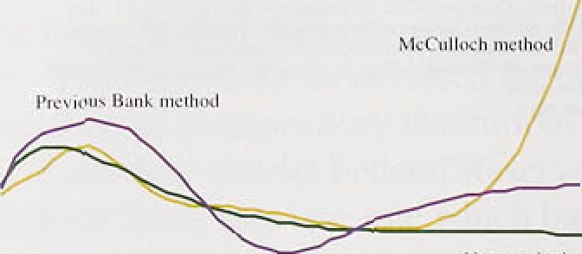





best guess.of where interest.rates:and inflation.will be in



implicitly' assuriies.’th'Jt''t iieo. margi.rial

to. find .!any.:'significaiit.

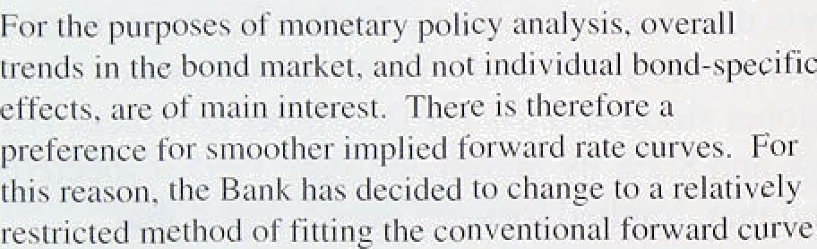

investor may pay.less for!'a b.on





**Cbart2.8**

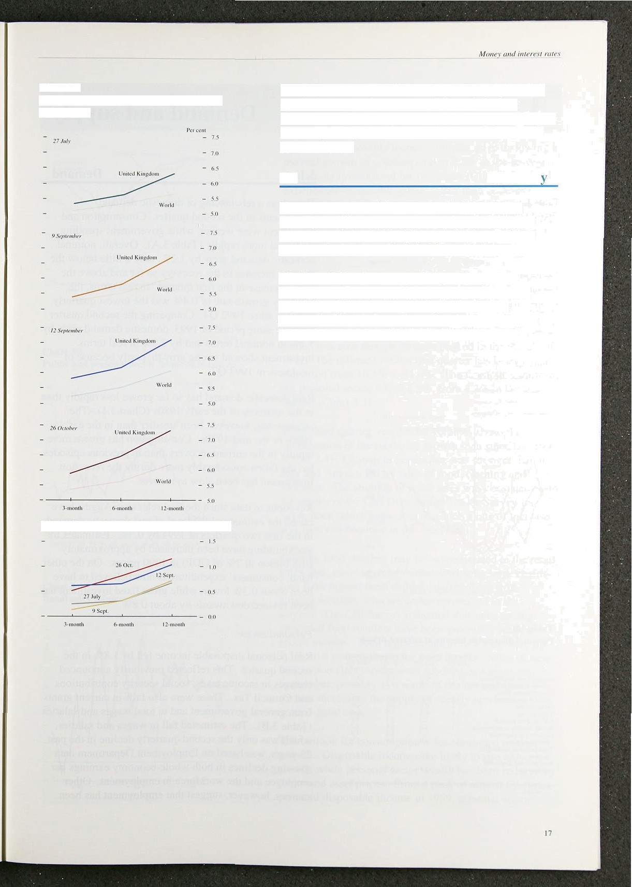

**UK and trade•weighted world interest rate**

**UX trade-weighted interest rate d1fTerentials**

expected depreciation of one currency against another equals the current interest rate differential—then sterling’s effective exchange rate is expected to fall over the next year by more than was the case at the time of the last *Report.*

##### 2.3 Summar

Broad money growth has remained subdued. The marginal fall in its growth rate was largely related to ***corporole sector activity.*** Narrow money growth *h'es* continued to be above its 0%—4% monitoring range.

The financial markets responded positively to the increase in official interest rates, suggesting that the credibility of the monetary authorities had been enhanced. Nonetheless, the markets appear to expect further upward moves in short-term interest rates.

 

Tnhte ?.A

**€iru»'th in d‹›mestic** demand







#### 3.1 Ddiñand

There was a rebalaiiéiEg.ofidomest}c.deman‹i components in the second. quarter, Consumpuon an‹i in.vestment.were weaker, while goverrirrient spendin.g i.ncreased more rapidly (Table. 3.A)..! Overall, norriinal domestic deriiaiid grew by l.2.&o, on:ly a.little below the' average increase in!the recovery soifar arid.ab.ove”the l..0% i.ncrease in.the first quarter: .In! real.terms, the quarterly growth: rate of 0.4.% was the lowest.quarterly increase since 1992 Q4. Comparing .the seeorid quarter with..the.same period'tof 1.993: domestic demand.grew'by 5.29• in nomifial terms.and ñy 2.89 i!ri real tertns.



Chiirt 3. I

Investment shpwed ,strong growth, weakness. in. I 9.93 Q2:

because. sf’

Real domestic ‹ierriand has so far groin less rapidly ethan.

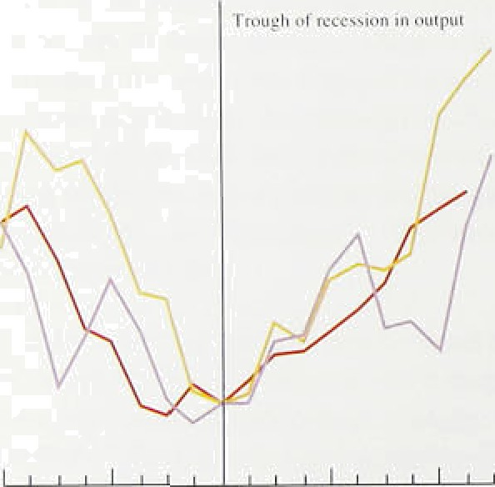

i.n the recovery of tfie early 1980s (Chartl3. 1).. Tire increase has, however, been steadier than in the early 1980s or the mf‹i-1970s. Consumptioii has grow.fi morg.’ rapidly in the current recovery than.in. previous epJso‹tes,. having fallen considerably more during.!.the.recession. Investment has..been.slow to: recover.

raiseñ the estimate: ofi!the.level of real.dorñestic demand. in the .first two, quarters,.of .19.94 by 0.3.%. Estlriiates for. stock:bu.il‹iing..have.beeri increased:'by approximately:



Talile 3.B

Pers‹inal disposable income **af current prices**







the second.quarter.'! his reflectéd previously a:nnou:need.

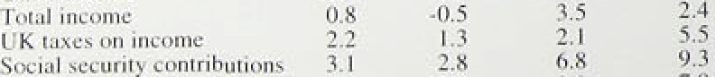

:changes iri!incoine taxes, social security contributions. and.Council Tax. !There were also falls in current grants fsom gqneral' govern.ment and.in.:tota:l



(Tañle 3.BI). The estimate‹i fall in wages an‹i.salaries,

. which.was on:ly the second quarterly decline in the past

R, ,r'//1 " b" -o:i -:.. o.i - 2' showing declines in. both whole-ecpnomy earnings per



1.8

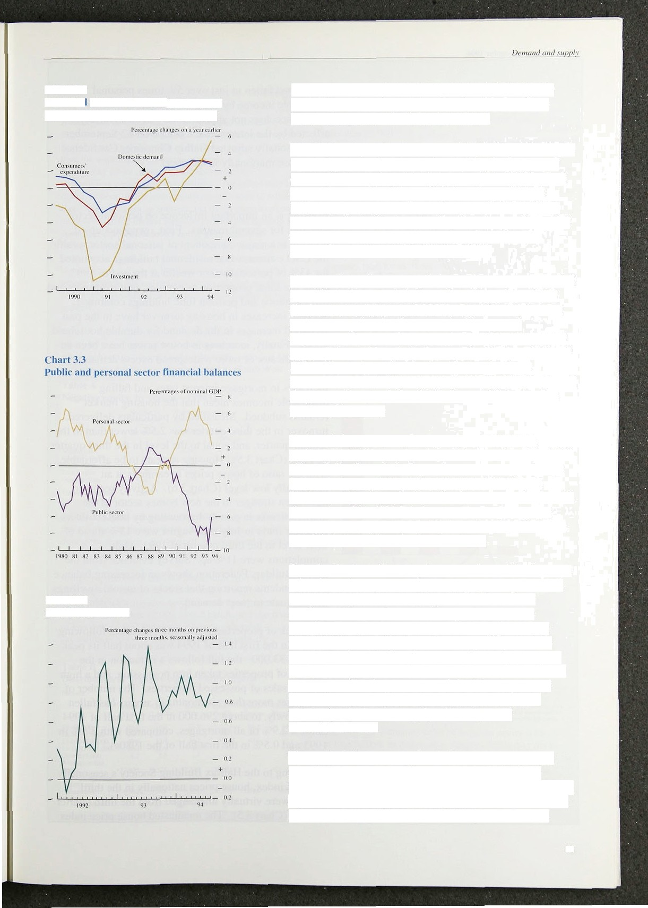Cbazt 3.2

**Real Iota domestic demaad, consumers’**

**expenditure and grnss fixed investment**

**Chart3.4**

**Retnil sales volume**

increasing. If so. disposable incomes and saving are probably underestimated (see Section 4 below for a further discussion of employment data).

The fall in disposable income contributed to a slowing in the real growth of consumptIOR tO 0.2& in the second quarter, its lowest level for two years (Chart 3.2). Real expenditure on durable goods (other than vehicles) increased by 1.9% during the quarter, the same rate as during the first. On the other hand, real expenditure fell on every main category of non-durable goods: for example, spending or food fell by 2.6%.

The slowdown in consumption growth was accompanied by a fall in the recorded personal saving ratio to 9.39r (its lowest level since late 1990). Revisions to income and consumption data have resulted in upward adjustments to the estimated saving ratio in the last two years; it is now thought to have peaked in the middle of 1992. The estimate for the first quarter has been

increased from 10.49c to 11.0%. The financial surplus of the personal sector fell to 2.3%, from 4.39c in the first quarter (Chart 3.5).

In the third quarter, retail sales volumes showed a continuation of the moderate growth seen since late 1993 (Chart 3.4). Growth in September was stronger than in luly and August, led by sales of food, clothing :ind footwear. The strength of retail sales was consistent with the results of the CBI Distributive Trades Survey for September, which suggested that such a rate of increase was likely to continue in the short term.

Sales by food retailers may be overestimated in the retail sales data, since aggressive discounting by large chains may have helped them capture market share from smaller retailers, who are underrepresented in the sample. The CBI Survey indicated that sales among specialist food retailers have been especially weak in recent months. Total registrations of new cars were up 3.3&• on a year earlier in the third quarter. Sales of new cars to non-fleet buyers were subdued in August and September, possibly as a result of dealers and fleet owners increasing the supply of ‘nearly new’

second-hand cars.

The outlook for consumption is for continued modest growth. Disposable incomes are likely to rise only slowly, while personal sector wealth has been reduced by depressed asset prices. From a peak of almost 6'/: times personal disposable income in 1989, personal sector

ln'lIation Report: Novemt›er t994







**t“hari 3.6**

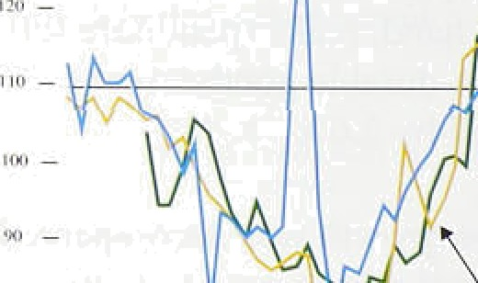

— 2

**Hume** price **t‹› earnings ratio*'**

20

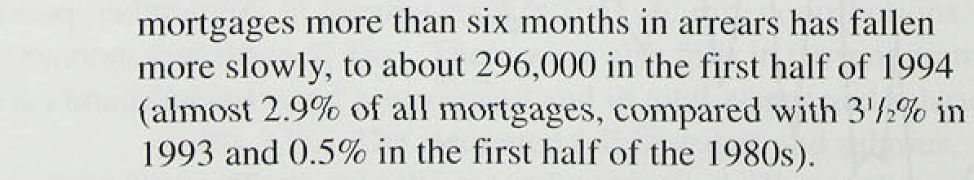

. :

wealth had.fal:len'to,just.over 5'/i times personal

disposable i!ncorñe by 1593: However, consurrier confrdence' does’got appear to have bleen adverse1'y



(the seasonally adjusted Gal.lup .Consumer Confidence’ Index .rose .marginal.ly in October)..

Housing is!.an im



demand, for several reasons. Firsl, owner-occupied ‘. housin'g is a major. ‹Component of };iersonat:sector wealthy the **CSO** estimates that residentia! .buildings accounted for 43% of personal.sector wealth at the..end!,of 1953, about the sarrie proplortion:as equities, unit tiiist units âiid. life assurance and pension fund holdings combined.

Second, increases in hohsing.turno.ver have:.i.n .ttte.past signalled .i.ncreases. in .the demand for, durable. household goods. Final.ly,. increases ifil housle prices.!have been:ari. early ifidicator 'of riiore wi‹iespre3d excess derfiañd.

Increases in mortgage interest rates anda .falling

.disposableuncomes mean that the housing market. remains subdued. Measured by particulars ‹delivered,. turnover in!the.tliird quarter cas 2.5% to.wer.than in the second.quarter, and equal to the .level .in ,the,ithir‹i.quarter of 1593 (Chart 3.5). .Housing, appears to be affor‹dable, with the ratio of house ,prices to’e ings at an historically lpw level (Cilart 3'.6).. Activity seems to have ñ1een stronger in the new homes sector of the market„ thanks: sn paft to.discounting by. housebuil‹iers.

" , Housing starts in July.anal August were l3&•’ ahead of theis level iri the .tliird quarter of 1993, while

- • completions were ll% up., .Survey evidence. from the House Bullclers.fiederafionishiows’an, increasing balance. of respondents reporting that\stoeks of unsold dwellings ”are a‹iequate-to meet.demand.

The stoek



„défault!in the'frst:ha!l!f.:of 1994.was About half its. peak: level,: at!33;000s tthe. fa:11’ foI/lows. a reduction in tiie

/tiumñéir of!:propefties.taken,init›’ possession;.and a high level,of sales..of possesse‹i properties. The’ numñer'of

According to thq Halifax Building .Society’s seasonally adjusted index, .house prices nationally in the third quarter were virtually unchanged frorfi the third.quarter of 1.993 (Chart 3.5). The unadjusted house price ihdex ,



Recent falls in **house.pricesi have** rénñweiJ interest iñ average. lével of negative 'eij'uitji'peF affected household i *s*

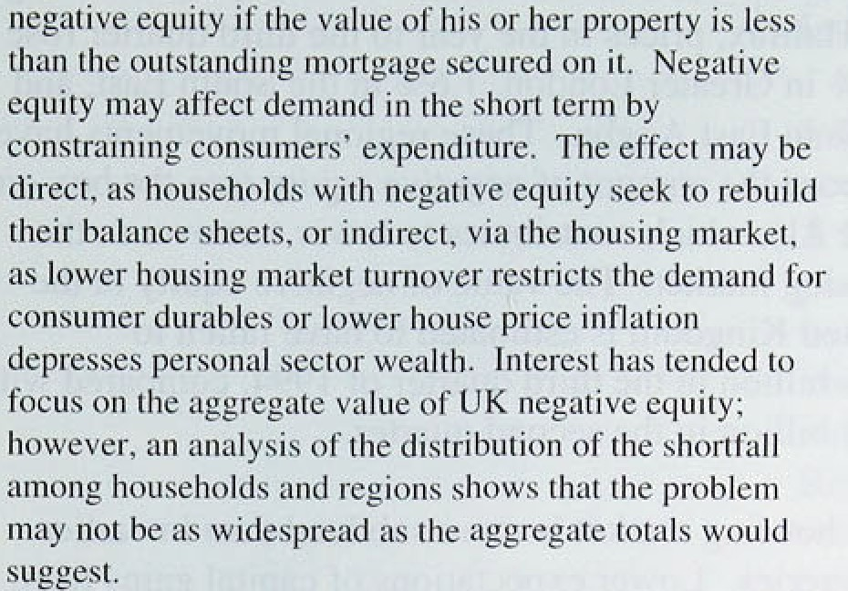négniive equity in.the housing anarkél: A.homéoñ ner has, ’ ”’less thaii £5,000.

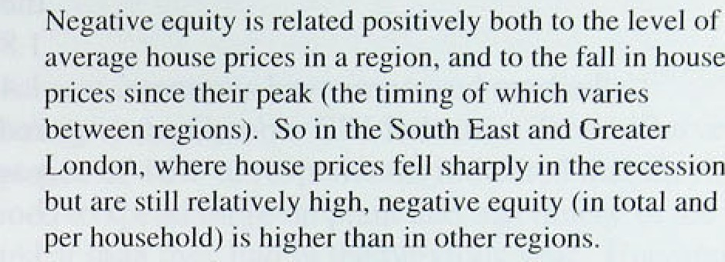

The distribu’tion of negative equity across households sug;iests ihat„ for most regions; relatively: modest increases. in .average. house prices wriuld eradicate the prub[em for a large number of households. Bank simulations show that a 5% increase in UK average .house prices. applied.ejuatly to:all regio°ns; w'ould reduce the totul value of negati.ve'equity by around two”fifths; a

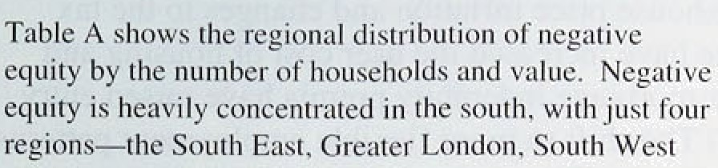I ()9o..increase would reduce it by over t:wo thirds:

Tabl°é A 

**'Negatiye. equityi** by : regi‹›ii—1994 Q3

_ ,





Uñ ited Kin di›m 1:h96 . S:566 t00

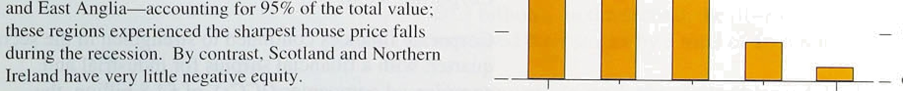

little nejntive equity:. of an.estimatdd I: l''':m'illion

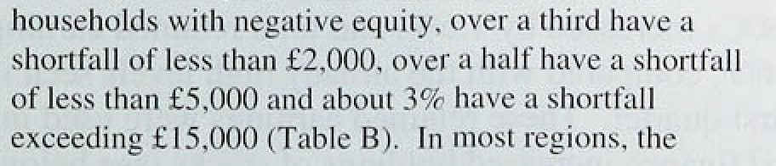



1994. Q3; dverage'house prices increases in-.the .four. ie%ioris with .ihe highest .levéls of ne%atvve equity ranged

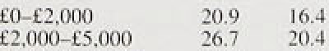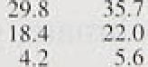

Sou'ih

Although /thé estimated value of. ne

—

!a sigriificant,constraint on Consumers. future béhaviour.

-P i c

lull:iiion Reports November 1994

published by the. Nation idé.B.ui1‹iiñg-Society; which has diverged fFom.tlie Halifax in‹iex.in recent mouths; increased by 2.9.&«.in-the ye,ar.toltlie.third quarter., Regional variation continues: for example, according ,to the Halifax, prices in lthe year:.to .the'tliird quarter rose.hy l.8% in Greater .London, 1.6% in the .South East, and 1.4% in East Anglia. These.regional mo.vements!ltave. reduced the amount of negative equity .(see the:box-on 1 page 21), which contribute.s to lower turnover irr.!the housing..market. The value of negative.equity in the Unfted Kingdom is estf mated to.have fallen to

£5.6 billion in the third quarter of’l994, compared‘w!iih

£6.3 billion in the second quarter.

The housing rriarket is. more subdued tlian. in..earllér: recoveries. Lower expectations .of capital gains from future house price inflation an‹i changes to the ta regime have increased the user cost of housing anfi higher mortgage indemnity prernia have raised•entry costs. The .shift to more .flexible employment patterns may have made potential .entrants to the market .more reluctant to take on mortgage commitments, especially as alternatives to owner-occupation are now more widely available. The difficulties in the mortgage market were reflected in the results of the latest CBI/Coopers and Lybrand financial services survey,

which showed that building societies were markedly l.ess optimistic about their overall situation than barilis.

t?hart 3.7

**C’‹irpurate** sector *ti* ri***arici* I* baliince and**

current account







2:"

*Corporate sec fur*

Corporate finances eofiti!niied to streng.thefi.in tile..second quarter,. with a .financial. surplus for i!ndustrial and commercial companies (ICCs); of £4.8 billion;. the largest,on record, slightly above that seen. iñ,the fifst.

, quarter (Chart 3.7). Gross tradi.ng profits, of.non.North! Sea ICCs. incr.eased.by 1..6&o,..arid total. retained eârnitigs,

' try 5,6%; compare.d .with tlie already h!igh lexe!s seen.iri the first.quarter. These:retained.earrings.were. used in. part to finance. iiicmâsed hol‹iings of.stocks (se‹i..b.eloa); Out eompanie:s.also repaid 22.31.bi.llion of b@k debt in





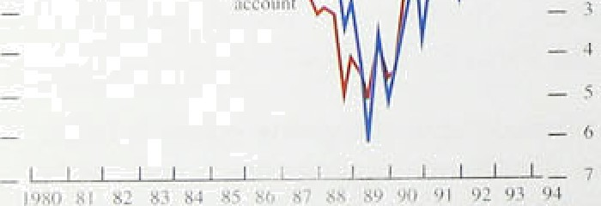low level. Net sterli!ng capi.tal! issues by UK ICCs were

£4.7 billion i.n the.second1quarter,. fi1 billion up on. the first quieter. ’

Despite the improved financial'climate, gross fixed investment fell .by 0.7&r in volume’terms in the second quarter. mves’tmetit in, plant an‹i machinery (34a of total i.nvestmen!t) increased by l.3Fo in the quarter, but spending on new buildings.and “works other timn dwelli!ngs, fell by 5A Manufacturing.investment w



 

by 3:79'r.in, the quarter,.but remained low relative to

.manufacturing or:tput. Although volatile from month to month, output of investment goods continued to grow:

’’ io,July and August it was on average 0.6% above its Q2

.levgl..

’’ Invest'ment intentions have improved markedly,

.aeeording to the .October CBI Industrial Trends Survey. A..balance of l6&o *of* respondents indicated that they planned to spend more on plant and machinery in the next year than they hafi in the previous year. Uncertainty about demand and inadequate net return were the main masons given as constraints on investment.

Replacement of **existing** plant and gains in efficiency 'were reported as the maln motivations for investment, but .tlie number of respondents citing expanding capacity

.as a reason was at its highest since.April 1990. Other surveys, such as that conducted by the British Chambers of Commerce, also indicate plans to increase investment. Taking the state of demand, company finances and survey evidence into account, there is every reason to believe that investment is likely to grow more rapidly in the near future.



Data on the stockbuilding component of GDP have been revised .to show increases in stocks in each of the first two!quarters. In the first quarter, the largest increase was in.tire,:manufacturing sector’s holdings of stocks (up

£0.3/ñiIlion); in the second, the distributive trades i:ntreased their stocks by a total of £0.6 billion.

The recovery in stocks has been more subdued in the

,ptirrerit cycle tiian i!n previous cycles. possibly because pressure on margins and techniques such as just-in-time delivefy have ma‹ie firms less willing to hold large stocks: If that is the case,!variations in stockbuilding

.may in! future bela less important i:nf1uence on short-term 'fluctuations:’in output. However, the employment increase.shown.by the Labour Force Survey ' suggests that the output of services, and .hence GDP(0), may be uiidefitated. lii .the expetiditure accounts, this woul‹i be [tefl@ted.in.](mailto:tefl@ted.in) an underrecording of stockbuilding.





Ciffi al. gnve:rninerii real fina!l consumption increased by

*’i*n the second quarter, with central government









llrlati ve ileiniiiid anrl c‹ists and the I raile b:Glance

- i (J

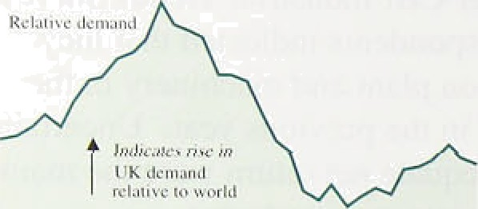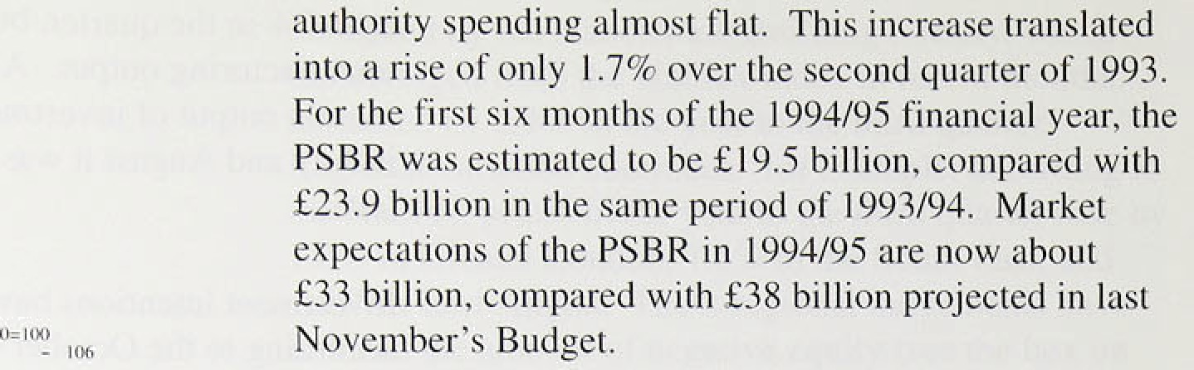

— i‹›s

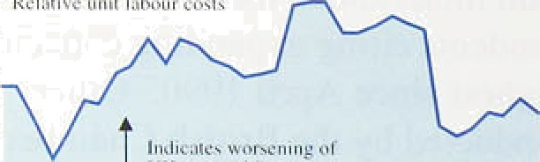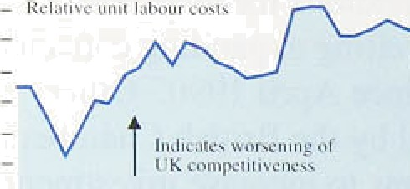

-

”

i‹x›

›3

›0

‹5

'- 80

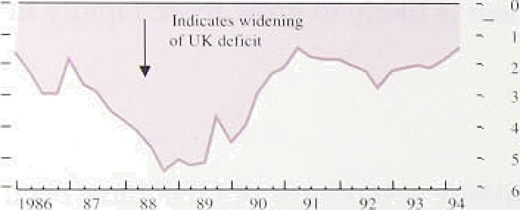



Pri›jecti‹›ns *t'‹›r* tiUP and 4ome*tic demgnd

yi u» th'•*







 







.24

Since .inflation has b.een.low.er.than was forecast;in. the Budget„ thetGovernment ca!n.rnaintairi tlié plannâd‹.real level. of spending for. 19 96 With .!owet nomifiil total. For example, nominal:soci;il security benefits wi!l be- increased.by less than was antici'pated, .sin‹ie iiiflatlon in the year to September was less:than;.projected. The!!

PS.BR w.i.l.1.a.lso be lower because of'the .higher level .of activity. The loiver..nom.trial f'SBR ,whirl I.n,.turri lovier the future path ofi.governme.nt delbt; the Budget projected that the ratio of gross .geñeral .goverñment debt to TOP would .peak.at .5 l'âo. .in l99S/97.



External. trade contributed 0.5 percentage, points .an‹i..

0.9 percentage.!points .tp UK o;ñtput growth.in: the first two. quarters of .1994. respectively, Th.e. contributions were the resul!t of strong growth in.’export:volu mesh.up: 7.2% „i!n. the first two gunners compared with the first hal.f of 1993. Import volume/s also.lose .over the. period;.. but by .only 5.8.So..! The. strong export .p:erfor;maiicd reflected robust demand. in ma)or export.markets, as 'wéll as iinproveinents in the price.coiiipeti.tiveness, of U‘K .industry since 1992 .(.Chit 3..8.). The. overseas

trade data for July suggested!these trends .were

!cofitiiiuirig.

Eiuri:ng .1‘993:„lthe major!source.of export growtb'Was. frorñ .outside .the European.Union': This.year;.’intra-EU

.the Europeaq



. :

Recent by

projections

demand \i;n',both 1954 and::l9S5 ,have /improved in many parts‹of the world .(Table 3.C).. In the United:States, growth. i's. projected.to sloU’in 1995 as the economy approaches fiull capacity; while the recoveries elsewhere are stil1’,gathering. morñentum. In Japan, .inciease‹i public "spending is boosting dorñéstic demand, .white in, Rurope iiet exports .(to areas such’ as Asia and the United States)

 

h ve: been a majlor source.of growth, but domestic de.matid is projected.'to strengthen..i.n 1995.

**Output components of GDP-at 1990 factor cost**



, .•e.›-’••















’.The Ufiited Ki'ngdom's external trade deficit fell to

£2:4. blltion .(1..7% of GD.P at market prices) in the second.qñarter, compared with £3.0 billion (2.1% of ”GDP) in .the first. The bulk of the improvement came froin oil and erratic items: excluding these, the deficit was £4. I billion in the second quarter and £4,2 billion in

.tlye, first. The change resulted from a narrowing of the deficit against countries outside the European Union,

where the deficit fe!l firom £2.1 billion to £l .5 billion. The deficit with other EU members was unchanged at

£0:9. ibillion, As the .European recovery .continues,

.ihis component of .the deficit can be expected to get

.smaller.

#### .3 2 S I

The recovery in output in the year to the second quarter was stronger titan previously thought. Total output iricreased by 1..1% in the second quarter, with the production sector growing more quickly than services (Table 3.D). Taking revisions to first quarter data into account, output in the first six months of 1994 is now



:estimated to have been 0.6& above the level reported in tlie .August *Inflation Report,* and.2.8% higher than in the first half of 1993.

North Sea output has grown particularly strongly in the pasl year—output net of this sector, which is perhaps a better gtiicle to the.state of .domestic economic activity,

!rose by 3.2% .in.the y.ear to the second quarter. As a result, real non-oil GDP pass#d the level achieved at the cyclical peak in 1990 Q2, having fallen 3.6% below this peak at the trough in 1952 Q1 (Table 3.E). The recovery is broadly based: among.the main components of ou@ut, the. mining an‹i oil,extraction industry has shown tire ggreatest i.ticrease (as a result of the influence of North Sea,activity), wiiile consnuction has yet to experience any significant growth. Manufacturing oiitput...although. recovering, is still be1t›w its previous





’Tire evidence añout output growth in the thir‹i quarter is mixed. The CSO’s preliminary estimate of GDP growth **in tb8 third ,t{uarteF iS 0.77c** .for.both .total **and** non-oil output. The’o.utput of the production .industries in July an:d iYugust..,showed.1:ittle: gai!n.over.the second q.uarter

iliougli tfiis woiild represent.gmwfh ,of over 4&o from

**.1 ,3Q3).** ANeidota1..evi‹ience **(inclu‹iing** reports from

If\Italian Report: November 1994 _ _ _

the Bank’s Agents) points to significant differences between sectors, and indeed companies. For example, some car plants are moving to short-time working, while others are planning to take on labour.

In contrast to the backward-looking production data, forward-looking surveys point to continuing improvements in the outlook for output. The October CBI Industrial Trends Survey showed that business

 confidence had risen (Chart 3.9), while optimism among exporters was higher than at any time since

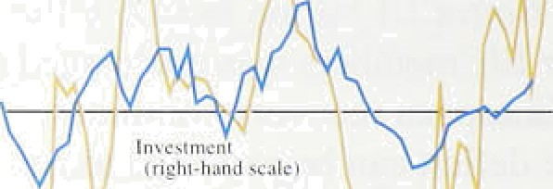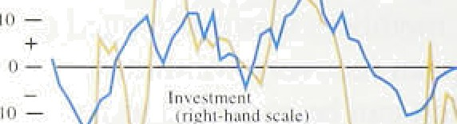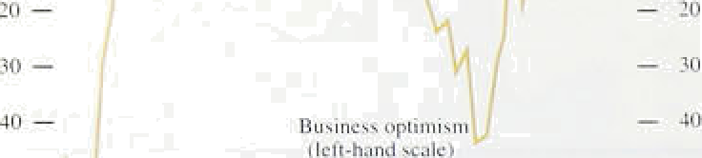

January 1985. The balance of firms expecting output to increase over the following four months was the highest since October 1988. A growing number of respondents quoted skilled labour and plant capacity as likely constraints on output. The Chartered Institute of Purchasing and Supply’s September Purchasing Managers’ Survey reported that almost one third of companies faced increasing difficulties in meeting delivery times. The overall Purchasing Managers’ Index fell for the second month in succession, but still indicated continued expansion. The British Chambers of Commerce Survey reported increases in the levels of home and export orders.



lt has taken four years for actual output to surpass its previous record level. Over this period, potential output will also have increased, although it is not possible to say precisely by how much. Examination of historical trends suggests a long-run growth rate in the range of 2%—2’/.%, but it has probably grown less quickly than this in the recent past as a result of lower labour force growth and reduced investment. But the output gap is substantially smaller than it was when output was at its trough, arid the prospect is for it to shrink further as output, driven initially by net trade and then by a recovery in investment, continues to grow faster than potential.

#### 33 S

The preliminary estimate of growth in non North Sea output was 0.7% in the third quarter, and 3.2&o in the year to the third quarter. Over the next two years, output is likely to continue growing at a rate faster than

long-run potential, and from a level closer to potential than was previously thought. Net external trade has been important in maintaining growth as consumption has slowed down following falls in disposable income.

Companies in some sectors are cutting back production in the face of weak demand, but in other areas they are

26



encountering capacity constraints. An upturn in industrial investment is expected following improvements in the financial situation of companies. The output gap is likely to be further reduced, but at a slower rate than in the recovery to date.

27

4



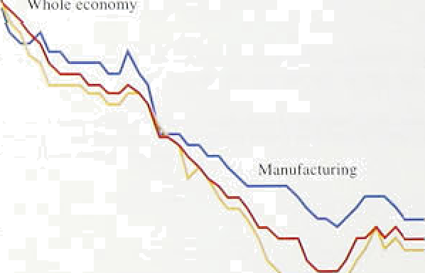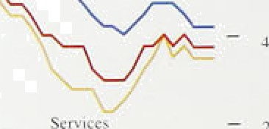





make i all t›T• *tncc s for rein porar;' i n l4 u cite es



V'' ages r«\I ‹4 I ari« x per he aJ 

Whole ecmun y acual aWr‹Q«



Whule cc‹›nomy und«rIyin H

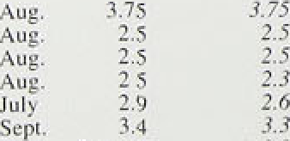

rate earning s fGreBi Britain )



I GS !r j

L R D itiJ it i



**The labour market**

#### 4 1 Ea n s

As the labour market tightens, the risk of higher earnings growth remains a threat to the general inflation outlook. Ai present, though, there is little evidence of this. The 12-month increase in the Employment Department’s measure of underlying average earnings is estimated to have been 4'Tc in Mny (revised upwards from 3'/‹% since August’s *lyflcition Report),* and 3’/‹% in June, July and Augrtst. The 12-month growth rate of actual average earnings also changed little, falling from 4.6% in May (revised up from 4.3%), to 3.8% in June and July and 3.77c in August. The growth rate of average earnings increased at the end of 1993, but has remained almost constant so far in 1994.

Annual growth of underlying average earnings in manufacturing fell by a '/• of a percentage point in both May and June, and remained at 4'/•9 from then until August—this was its second lowest rate of increase since the current series began in 1980. In the service sector, underlying earnings growth remained at 3'/i% between June and August, a '/• of a percentage point lower than in May. But, unlike the rate in manufacturing, it remained well above its most recent troup•h of 2’/‹9a, which was reached in October 1993 (see Chart 4.1 ).

Settlements data are mixed. In August, for the seventh consecutive month, the Industrial Relations Services (IRS) measure of median pay settlements remained at 2.5' •. The Labour Research Department reported that the three-month median of settlements rose to 2.7% in July and August from 2.5% between January and May, but then fell back to 2.6% in September. The **CBI** reports settlements rising. Between the three months ending in June and the three months ending in July, it found that settlements in the manufacturing sector had risen from 2.69c to 2.9% (see Table 4.A). Incomes Data Services, in their October report, noted that the proportion of settlements being agreed at 2% or less has continued to diminish, and there are some initial signs that autumn deals may be moving higher. These findings should be treated cautiously, because only a few settlements are concluded during the summer months arid those that do occur cover only a small proportion of

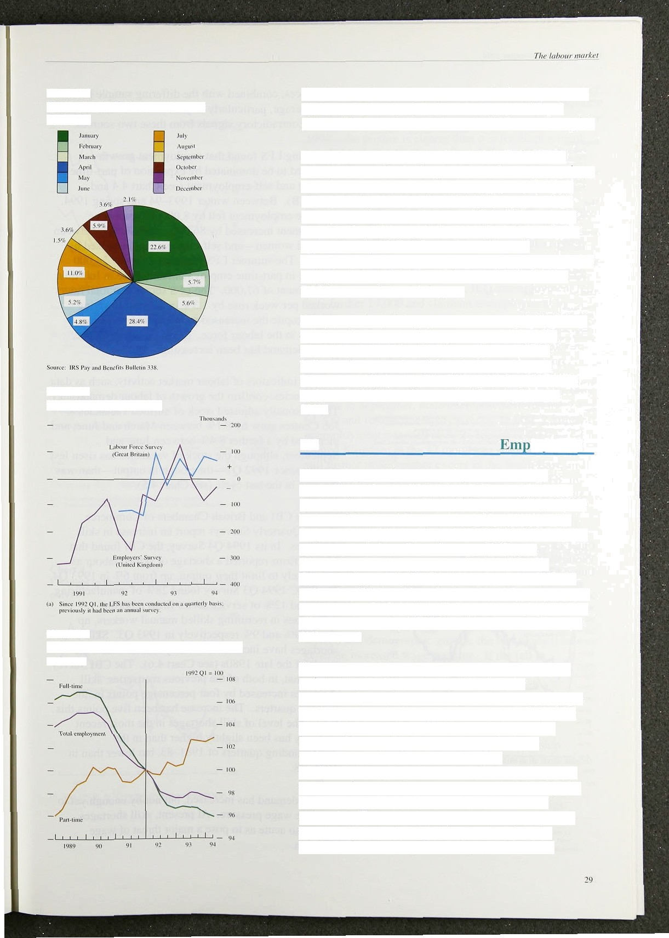**Chart 4.2**

**Proportion of 1992 pay settlements by month**

Chart *4.S*

**Changes in employment** ›

**Chart 4.4**

**Full and part-tlme employment in the lstest recovery**

the UK workforce. Usually, over half of all settlements are made in the months between January and April (Chart 4.2 shows the breakdown in 1992 as an example).

Bonus payments have been less important in recent months than earlier in the year. Actual average earnings, therefore, have not been affected as much by one-off increases. The contribution of overtime payments to average earnings is harder to establish. Data are only available for operatives in the manufacturing sector— approximately 12% of the total workforce in employment. Total overtime hours for these workers fell by 3.4% between March and June. and fell a further

7.1% between June and August.

Many wage-bargaining agreements are explicitly linked to a price index—almost always the headline RPI, according to the CBI. The 12-month rate of RPI inflation is expected to pick up in November and December; any increase may be built into settlements at the end of 1994 and, more significantly. January 1995.

###### 4.2 loyment

Has employment been increasing or decreasing? According to the workforce-in-employment measure, total employment in the United Kingdom fell by 35,000 between March and June, and by 9.000 in the year to June. This conflicts with the findings of both the spring and summer Labour Force Surveys (LFS) (see

Chart 4.3). They found that total employment in Great Britain rose by 80,000 between winter 1993—94

and spring 1994, and by a further 65,000 between spring and summer. In the year to the summer, employment on this measure rose by 226,000. What accounts for these differences?

The summer **LFS** covers the thi’ee months to August, so it is two months more up-to-date than the

workforce-in-employment measure. More importantly, the LFS estimates the number of people with jobs and shows that the number of full-time employees has increased less rapidly than other categories (eg

self-employment, part-time work). The

workforce-in-employment measure is derived from an employer-based survey which counts jobs. and appears less able to identify job generation in these other categories. For example, some workers on temporary contracts may not be counted as employed by the employer-based survey, but are by the **LFS.** Such



"l“alile 4.li

I.’11ii ngm **in viuJil‹›\** is1enti*i



E niplos'ecs

fielf•eni plos-ed

P ull• i inic ?(





”1otal i ii i -2d 74 7 gtl 65











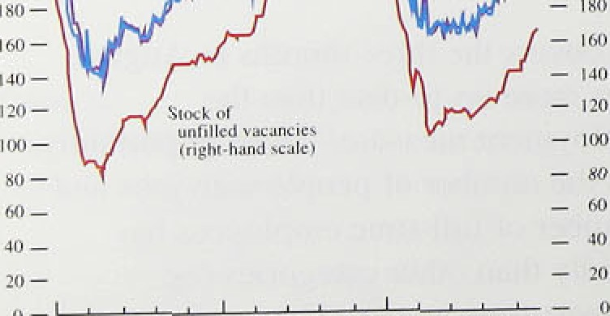

30

differences, combined with the differing sample periods and coverage, particularly of jobs in new firms, account for the contradictory signals from these two sources.

The spring LFS foiind that employment growth continued to be dominated by expansion of part-time working and self-employment (see Chart 4.4 and

Table 4.B), Between winter 1993—94 and spring 1994, full-time employment fell by 8,000, but pan-time employment increased by 86,000—split evenly between men and women—and self-employment increased by 41,000. The summer LFS recorded a further 24,000 increase in part-time employment and a rise in full-time employment of 67.000. The LV-S shows that total hours worked per week rose by 1.3% in the year to spring 1994, despite the increased proportion of pan-time workers in the labour force. Based on this evidence, labour demand has been increasing.

Indirect indicators of labour market activity, such as data on vacancies, confirm the growth of labour demand.

The seasonally adjusted stock of unfilled vacancies at Job Centres grew by 8.1% between March and June, and increased by a further 8.4% between June and September, although the stock of vacancies has risen less rapidly since 1992 Q I—the trough in output—than was the case in the last cycle (see Chart 4.5).

Both the CBI and British Chambers of Commerce (BCC) Quarterly Surveys report an increase in skill shortages. In its 1994 Q4 Survey, the CBI found that 109c of firms reported a shortage of skilled labour as most likely to limit their output, up from 6% in 1993 Q4. The **BCC** 1994 Q3 Survey found 289a of manufacturing firms and l2Yo of ser vice sector firms reporting difficulties in recruiting skilled manual workers, up

from l99• and 9% respectively in 1993 Q3. Skill shortages have increased, but they remain below the levels of the late 1980s (see Chart 4.6). The **CBI** Survey shows that, in both of the previous recoveries, skill shortages increased by four percentage points in the first fen quarters. The increase has been flve points this time. The level of skill shortages in the most recent recovery has been slightly higher than in the corresponding quarters of 1981-83, but lower than in 1975—78.

Labour demand has increased, but not by enough yet to generate wage pressure. At present, skill shortages

are not so acute as to pose a major threat of wage inflation.

 





 







L,tqi. ,qpf ,pe

#### 4 3 Une lo ent

All measures show that unemployment has fallen in

199 the! picture is clearer thaii it is .for employment (see Table 4.C). Clai.mant.unemployment was

.!2.5:7. million in September, 9.1% of the workforce. The claJ:mant count between June and September and by 336,000 in the year to September.



The.spring and summer LFS confirm these findings (see

.Chart 4.7). The spring LFS recorded a fall in ILO u!nemployment( ) of 79,000 in the. three months to May

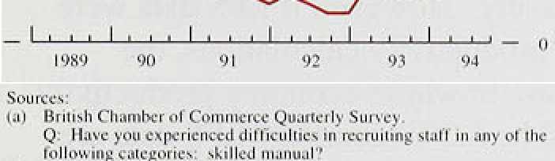

!compared with the previous three.months—a period in which.the UK claimant count fell by 83,000. Between tire spring and summer surveys, ILO unemployment fell by a.further 14,000 and claimant unemployment by fi3,000:

The fall in unemployment. while not entirely uniform,

has affected all the main categories .of the workforce.

.Both male and female claimant unemployment have

.fallen in every month bar one since January. In the three months to September, male unemployment fell by 64;300. and female unemployment by 13,000. Claimant

2,: :unemployment rates fell in every region of the

"" °°’!'* •"'•* Unite‹i .Kingdom ih the 12 months to August, and fell



**Cliangés) id”’unempIbyinenC’(Grdat:Britain**







the: year.to suñiñier 1994, ILO unemployment.rates also fell in all but two regions.. The average fall was 0.9!:percentage points. The exceptions were the North West—.where the rate remained unchanged at 10.6%—

:and.the.East.Midlands, where. it rose from 8.8% to 8.9&<. Si:iñi1ârly,.I!LO unemployment rates fell for all age groups,. apaft. from men aged over 65 and women over



The.: more’uñiform is the fall in unem loyment across

’regions.and demog:raphic groups, likely it is to

the less

generate increased: wage pressure. If the fall in unemployment were concentrated in only one region, for exaiilp1’e„ that .local labour market might reach a

'bottl nefik’, .forcing loca1!wages up. Divergent regional.uriemp1oyment rates imply .higher aggregate wage inriauos for a gi:ven..level:of nationa:l u'nemployineiit, if tlie typical regional relationship between wage.inflation anfi.u9employment is non-linear. **Mgion6i/ ui** employment rates are:,now less dispersed that in thee pasi, which may help to.:account for the

' lower-,th an-ex:pecks inereas’es. i!n nominal eñrhi:ngs.



**:foJlnwing**

 



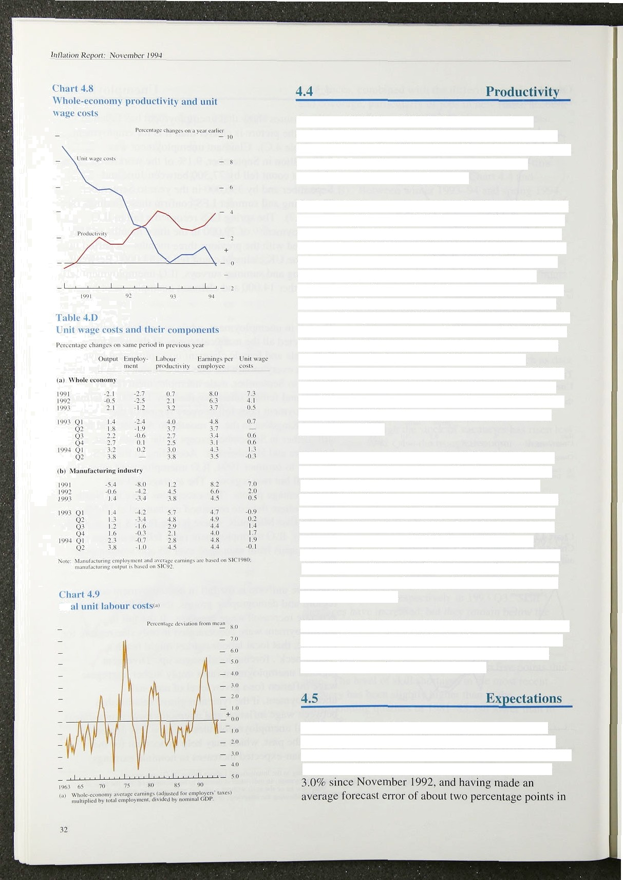

Between 1994 Ql and 1994 Q2, the conventional measure of the annual rate of productivity growth rose from 3.0% to 3.8%. This reflected both the I.I % growth in real GDP in 1994 Q2 and the slight fall in the recorded workforce in employment.

Productivity has now grown by 8.5% since 1992 Q1, the recent trough in output. This is very similar to previous recoveries. In the nine quarters following the trough in each cycle, 1975 Q3 and 198 l Q l, productivity grew by 8% and 10% respectively. However, if LFS data were used as the basis for productivity calculations, the estimate of the increase in whole-economy productivity since 1992 Q I would be 6.2% (quarterly LFS data are not available prior to 1992). Slower productivity growth in the recovery is consistent with increased flexibility in the labour market. With easier hiring and firing, firms should be less inclined to hoard labour during a recession—productivity actually rose between 1990 Q2 and 1992 Q2—and more inclined to hire in an upturn. possibly on temporary contracts. The more flexible the labour market becomes, the less volatile productivity growth should be.

Whole-economy unit wage costs fell in 1994 Q2. to a level 0.3% lower than a year earlier, having fallen by 1.6% since the previous quarter (see Chart 4.8 and Table 4.D). The four-quarter growih rate of unit wage costs remains more than five percentage points below the average level for the l990s. In 1994 Q2. real unit wage costs were around l % below their long-run average, having been more than 5&o above the mean in 1992 Ql (see Chart 4.9). This change reflects the fact that average real earnings growth has not kept up with productivity growth.

Mt›re timely data are available for manufacturing, where productivity grew by 4.99r in the 12 months to August, down from 5.7% in June. Similarly, unit wage costs were 0.3% lower in the year to August.

Gallup’s survey of inflation expectations shows that employees’ price expectations continue to adjust very slowly. Employees expect RPI inflation to exceed 4&o in 1995, despite having seen actual **RPI** inflation below

*!The lyI›nur market*

1993‘and 1994 so„far (see Chart 4.10). This is worrying, because although monetary policy will not validate inflation outside the target range, excessive price



'•" .expectations may lead to unnecessarily high nominal wage claims and lower employment. This is particularly

i tlie,case in wage agreements which are multiple-year

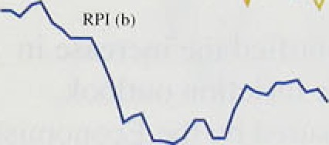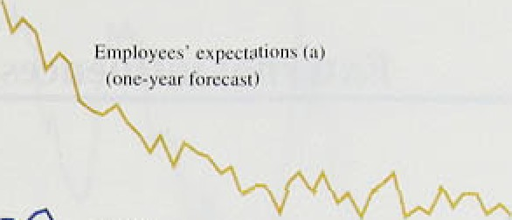

p„,

.deals:

.However, as. noted in the August *Report,* evidence from

_ , the: Barclays..Basix Survey.showed that the price expectations of general secret:aries of TUC-affiliated trade unions,.although still above the actual RPI outturn, wefe.:1ower than.those.of employees.



Labour demand has increased. Employment evidence is

.miXed, but the Labour Force Survey found an increase in Sotli employment and total hours worked in the three months to May compared with the previous. three riiohths. The increase in employment continued in the

'tliree months to .August. And the growth in the stock of xacaficies over the same period confirmed the increase in labour deinand. Unemployment continues to fall. For given expe1ctations of inflation, this tightening of the labour inarket woulii be expected to push up nominal ear*i.rigs. .So would the growth of labour productivity if

**.it:had:.been** faster than the growth of real wages. But, although there is some evidence of an increase in skill

:stiortages. and séttlements may be edging upwards, these

.have .not yet.led to.an acceleration in nominal earnings.

.At.tlie rñoment, it is .uncertain whether this is because inflation expectations have fallen rapidly enough to counteract these factors, or because earnings growth is

.aboiit.to move .upwards:





5.1 





The August *Inflation Report* identifiii‹i the ihciease in, commodity prices. as a .risk to the inflation..outlo:ok: Non-oil comrfiodity prices, treasured by the! Ecooomis!

sterling index, fell .duri.ng the three 'rrionths to'the!.middle

, of October. as several..food .and:agricu!ltural product

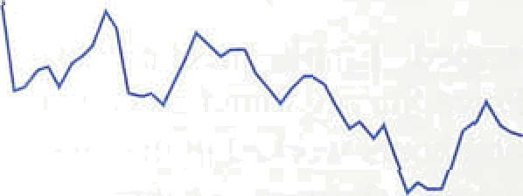.prices w.eakened. In particular,. tiinber prices fel!l by over 159a as a result of an .industnal.. re1ations!dispute

' during the period,. anal adverse weather conditions

'• affected a number of food produét prices. Metai prices, however, continued to increase. LOoking lat non-oil.

” commodity prices over the year, the Econoinist index shows an annual increase of around 30% to

*,* mid-October. Using.a UK. trade-wei%hte‹i sterli!9g index.

, the Bank estimates that nori-coil coinmodi.ty pnces increased by just .over.1.7% in the. year.

ii

I ’hurt 5.2

Ste rling n‹iii-oil coiiiiiiodity prices

Because of the fall iii oil ,prices from .thgir. rqcent peak.1in. the second .half of.July, sterling commodity priées including oil fell. by nearly 12% .from t1ie:end o’f July, resulting. in an annu;iI rate.of increase. to mid-October of under 3%. Brent crude oil prices ha.ve’fdlleii b,y'around 13.' o in the past three months reFlecti!ng'suppJy developments, suchl as the compJetii›ti.!of ñiaintenarice’ work in the..;North Sea, the ending of.’the N!geri.afi:.oil

„ .workers’ strike and air easi.iig of téiisioiis.:iii!the .Gqlf (see Chart 5..1).

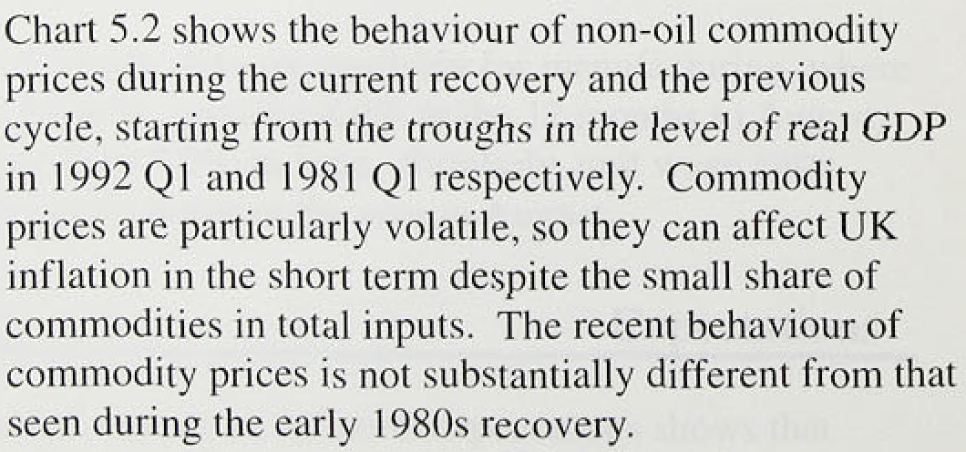+

— 0

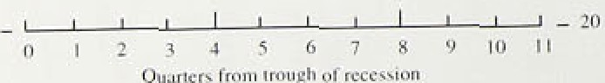

Chart 5:3 deflates.the onoinist index.using an indqx of G7 producer.pfiées (all:series are.denominated.in US

,‹dollars). From the .trough in the. third:quarter of 1993,

.ielative,coinmodity pricles have increased by around





27a . .Comparison with the previous **recovery** suggests thai ,commodity prices could rise further as the world ecqnomy reco,vers. Real commodity prices, ho wever,

p .have fallen by around 30% since the early 1980s,

' ' .suggesting that non-oil commodities have declined in

- « .importance as factors of production.

Anecdotal evidence, including reports from the Bank’s

.Agents, suggests that the rises in primary commodity  prices. are begi.nning to feed through to intermediate

stages of the supply chain. Material cost increases are feeding through in the metals, piper and board, chemicals añd building materials industries in particular. But many firms are.having to absorb or offset increased costs .because price increases further along the supply chain are.diffilcult to achieve, There is a risk that more of,the! increases in costs could be reflected in prices in the future.



*Overseas inffntion and import pri‹’e.s*

Chart 5.4 shows that,the annual .rise in producer prices in the major six economies remained subdued in the first six months of .l!S.94, although recent data from some

/countries suggest that inflation has since picked up

,slightly. The .latest IMF *World Economic Outlook* argues that, unless world output proves significantly stronger 'than"iiow forecast (3.1 % in 1994, 3.6% in 1995), there is

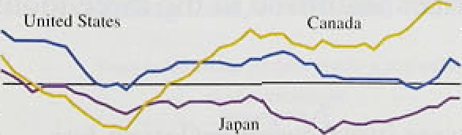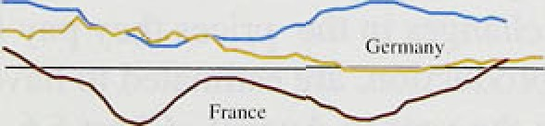

.little risk of a general pick-up in inflation in the near teFm, despite the significant rise in the prices of some primary .goods. If expansion does prove stronger, however, .concerns about risiiig inflation would be warranted. The **extént** to which foreign currency prices **fee‹1** through to domestic inflation is determined by the exchange rate. If the exchange rate always moves to offset tlie difference between UK and foreign inflation, overseas price increases will not feed through to UK

:i.fif1ation:.

**Alihougli** iinport prices have not al.ways responded fully to changes in the exchange rate, some increase in impori prices was expected after sterling's fall in September

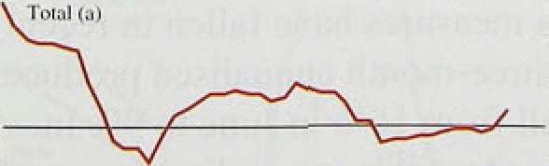

general, an'exchange rate:change is l.ikely to pass through rapidly.aitd’fully into import prices if the importe’d goods are.homogeneous in nature and traded in

. competitive markets, and if,.the exchange rate change is eRpeeted to be permanent. Pfices of non-oil imports rose by just under l6& between 1992 Q3 and 1994 Q2. In the.some period,.the sterling effective exchange rate **deyftciated by 12a.:**





With !w orld export‘prtces (in .dorriestic currencies) ri’sing

.by around .t.Jo in the fi.rst two quaners .of 1994,.there may. have b.een an i:ncrease in foreign exporters;” margins

!on. goods ’sold to the U.nited. Ki.ngdom compared with

%oocls sold,.to other iiiarkets,\which could' be explai.ned by ,.foreig.n proclucers. taking adFaniage of.the stronger dema.nd lñ thel.UK.marke“t:

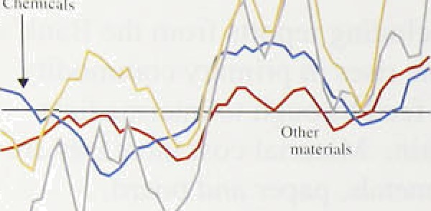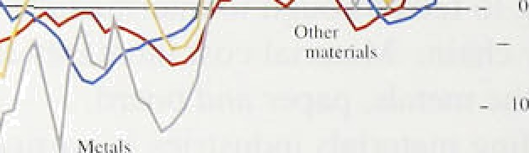

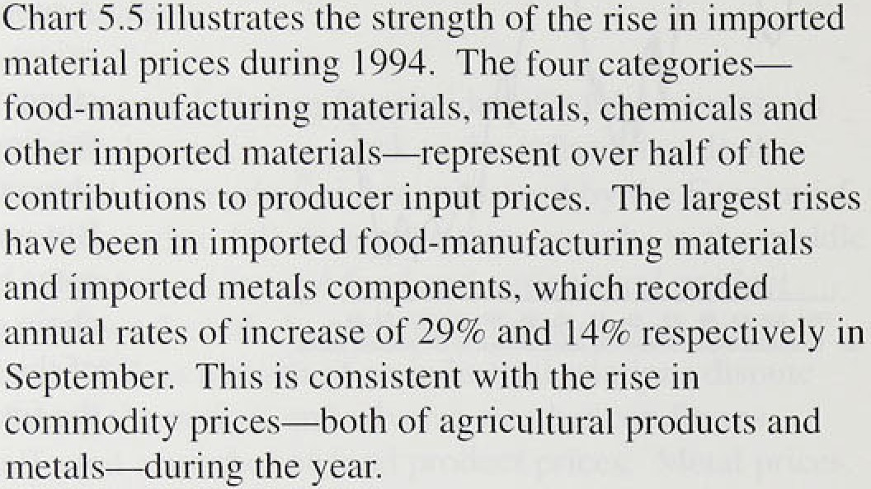



Tâblé 5.A shows how movements in input pricles have fed through to manufaéturers’ output ,prices.! .Costs have remai.ned subdued—weighted a.verage costs„are

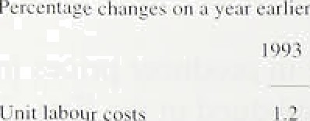

,éstirriated. to have increased by'.I .4to .i.ri the .yeat to



.Au .ust.. 'fi.nit l'abour. closts hate..fallen (by 0:5%. in’the. year to AvgustJ,.partly .offsettiqg the growth in

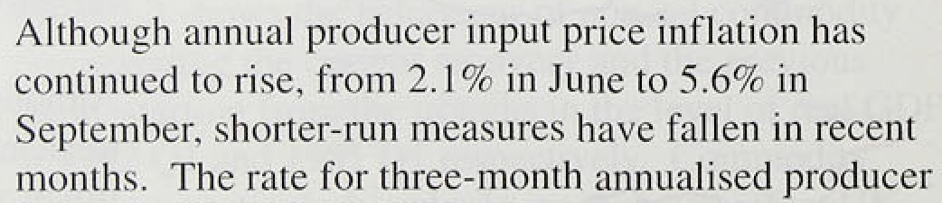rri5n u.facturing..iim.port prices:. Manufacturers’ margins, calculatecl'by coinpating.;changes in.,fi!rrps’ domestic output prices with' the .changes in the prices they .pay for the *riou’s fa.ctprs of.production, are estiin’ated to have groivn. by .nearly..4to in..th’e year to August. Chart 5.6 'stiows'that,estimated in;inufacturers’ rriargfris as a proportion of ou!tput prices stabilised in the three inonths to A.ugust.

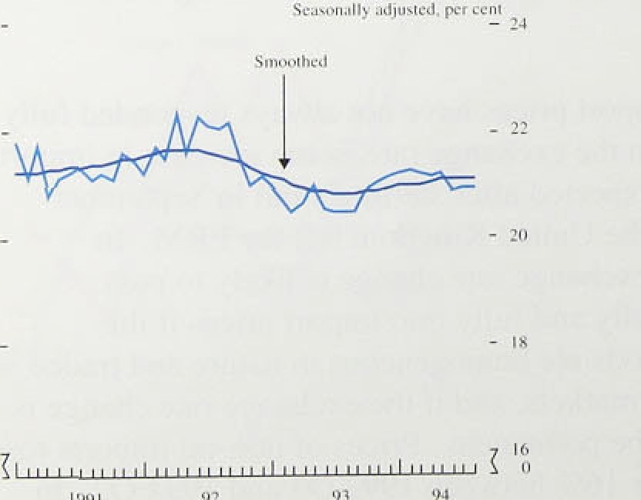

i!n:put price in!flation fell from l 6% i:n.June to 9ér in September: .In. the near:terrri, this may rel:ieve. some!of. lhe pressure ion..inanu!facturérs’ margins.

Ban:k estimates suggest that ritailers’ margins fell by' arou;nd 10% iri the. year to the. seconfi quarter.of 1594: As.noted earlier, althougfilcosi pressures are.emerging at. interinñdiate stages' of the supply chain, il does not yet appear that retailers are able to rebuild .lheir margins.

The presstire on retail rriargins.has persisted for longer



**Cliarl 5.7**

**Profilahilii '‹°› in the: lust three**

**recessions/rec‹lvcries**

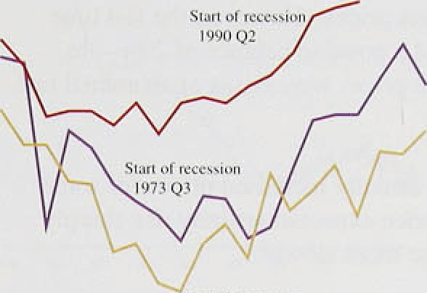

than expected. .One consequence of’ the further fiIScounti.ng, particularly in the food and second-hand car markets, as‹ttiat..retailers. mlght not be. in a position to increase theirtmargi.us.over the next quarter.

The latest CBI Quarterly Industrial Trends Survey repone‹i that a. séaâi›nal.l.y adjusted balance of 22*Vc* of manufacturing firms. expected to raise prices over’ the follow.ing four months, compared with 20% reported in July and 1 29 reported as achieving higher prices during the past four months. And al.though prices fell slightly in Septerñber, the Chartered Institute ct’ Put chasing Supply Purchasi.ng Managers’ Index remained at a high level.

Prices rises were. attributed to supply problems, as well as to commodity prices.

##### .Profitability



.Profitability is best measured by the rcturns firms earn on the capital they employ. these depend, in turn, on how prices .move relative t(› costs.and the extent t‹i which capital is utilised. Chart 5.7 shows that the strong growth in profitability is in line with previous recoveries,

:although it started from a si.gnificantly higher level. Profi.tability has been less volati.le in the latesi cycle than 'in the previous two, largely reflecting cost control in this recovery so far.

Chart 5.8 shows changes in manufacturers’ output prices and .the costs of the manufacturing sector. On a seasonalI.y adju.ered basis, output prices (excluding food, beverages, tobacco and petroleum) rose by 0.3°/o in July arid Aug.net, and 0.47• in September. The annual



:inflation rate .rose slightly. front 2.0%c in June to 2,1 Mr in September.

The **CSO** outpul price data tend to understate emerging

.pric,e pressure;s ,in. the econom.y because they do not measure price increases paid by firms to companies in the same sector. Users!.of steel, paper, chemicals and

’’ bui!lding materials. have faced significant cost increases

.ivliich have not yet fed through to output prices. Output price'i,iiflation,might.therefore.rise over the coining inonths,,.with!firms seeking to pass on rising costs further



_ ..’ , ., The relationshi:p‘between r.etail.prices.ind producer

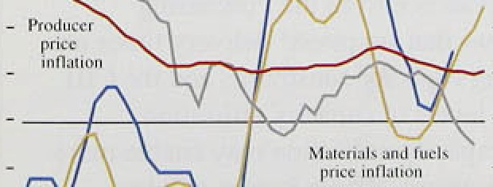

i 99I ' : 9d. . 

Producer prices clear1.y because.of wholesale c.osts, but retai.l

prices may **affect** producer prices throu:gh wages and



#### Producer output prices

*CB*

**Chart5.9**

**Ratio of RPIY goods to producer pricm•i**

other costs. Chart 5.9 shows the historical behaviour of the ratio of RPIY goods prices to producer prices. The downward trend shows that it is possible for producer price inflation to be above **RPIY** goods infiation for long periods.

The extent to which higher input prices are passed through into higher output and retail prices will depend largely on competitive conditions in product markets. for example how far potential supply exceeds demand, and on trends in other components of manufacturers’ costs.

The impact of rising material costs may be offset to some extent by favourable movements in unit labour costs, which have been on a downward trend throughout this year. Firms can also maintain profitability by increasing volumes and by further productivity gains (see the box on page 38).

**Summar**

The rise in output price inflation is consistent with recent survey evidence from the manufacturing sector, which suggests that larger increases are in store. The strong increase in input prices seen earlier in the year has begun to feed through to manufacturing industries’ customers. With the continuing rise in commodity prices pushing up manufacturers’ input prices. output price inflation may well rise further in the near future.

39

 

This section presents the Bank's projection of inflation over the next two years. As usual, it is based on ,the assumption of unchanged official short-term interest rates. The projection incorporates the Bank’s judgment about the impact of the '/2 percentage point in‹irease1ln official rates on 12 September and the economic news since the previous *Report.*

###### 6.1 The news

It is desirable to use all the relevant information about the state of the economy to assess the future’path of inflation. That is why the previous sections reviewed a wide range of data on monetary and real developments. But it is helpful to summarise ,the main pieces of news from the past three months .to put the projection in context:

* + - Official short-term interest rates werelincreased by 50 basis points on 12 September.

Retail price inflation,.has fallen. further—an‹i has! been a little lower than the Bank’s short-term projection of three months ago (ñy about

0.1 percentage points averaged.over the quarter).

The main .monetary aggregates continue to give conflicting. signals. Narrow!money.growtl: increased more than .expected—and remains well above its 0%—4% monitonng, range.,’But broad money growth fell, and.remains:conifortab1y!inside its monitoring!range..

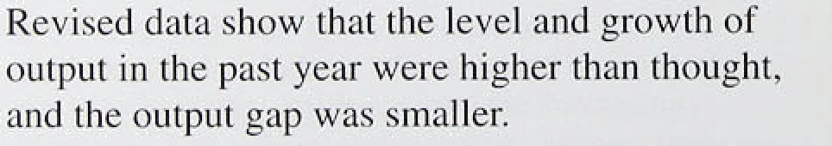

Unemployment:éyfiti.n,ued.to fañ and employment. probably.!kc:reaséd.during the sprihg and s er.’ Lower.excess:sagp1y'!in the labour markyt.has not yet Hed to.mere:rapid.gr th of’ae ige. earñings,

.!although settlements have.been edging up.

 Manufact**urérs’** annual input price inflation—



**Chart 6:2** .

!.co:mmodity prices!are much higher than a year ago. The increases.have begun to feed through to output prices; factory-gate inflation has shown signs of

!inereasing,. and.surveys of price expectations suggest this will continue.

fi:2 The Bank’s medium-term inflation

*o* ect o

The economic news .has led the Bank to lower its medium-term inflation projection. This section explains why.

The evidence about output growth—a narrower output gap closing more rapidly—would have led. on its own, to an upward revision ,of the .projection. Moreover,

.European growth prospects are better than they were three inonths ago, and import growth has fallen. Hence a:.bigger contribution to growth from net external trade is in prospect.



. ’ . , This, ttas been outweighed by:

R. The impact of the interest rate increase: this will slow down the growth of demand, first by encouraging higher saving and .reduced borrowing, and secon‹i by reducing .the disposable income (after interest payments) .of indebted households and companies. The effect will probably be greater than might have been expected on the basis of past episodes, because .of the continuing high level of indebtedness of the personal sector. It is also possible that .the signalling effect of an increase in rates earlier in .the recovery than many ha‹i expected might lower inflation expectations.

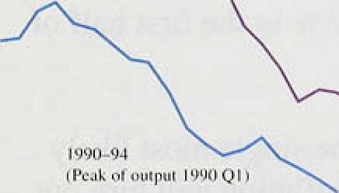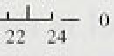

**'CDP.devtattoa’.I'rom::trend:** ”









*N* Recent price developments. inflation has again turned out a little lower than expected, despite the fact that the.:output gap in .the past year or so was

.s.ma1ler than thought at the time. A given output

!gap now.appears to have slightly more of a disinflationary impact than.in previous cycles. There is evidence of.further aggressive discounting by:.cetai.lers; especially in the food sector, which may file/ct a permanently higher degree of price competition and”iniiovation in the sector. If so,

' tfier6 has beeii a faâo.u b! e supply shock generaung:,permanently higher output‹and lower



than,expécted,.in .the:’light! of past prodiictivity

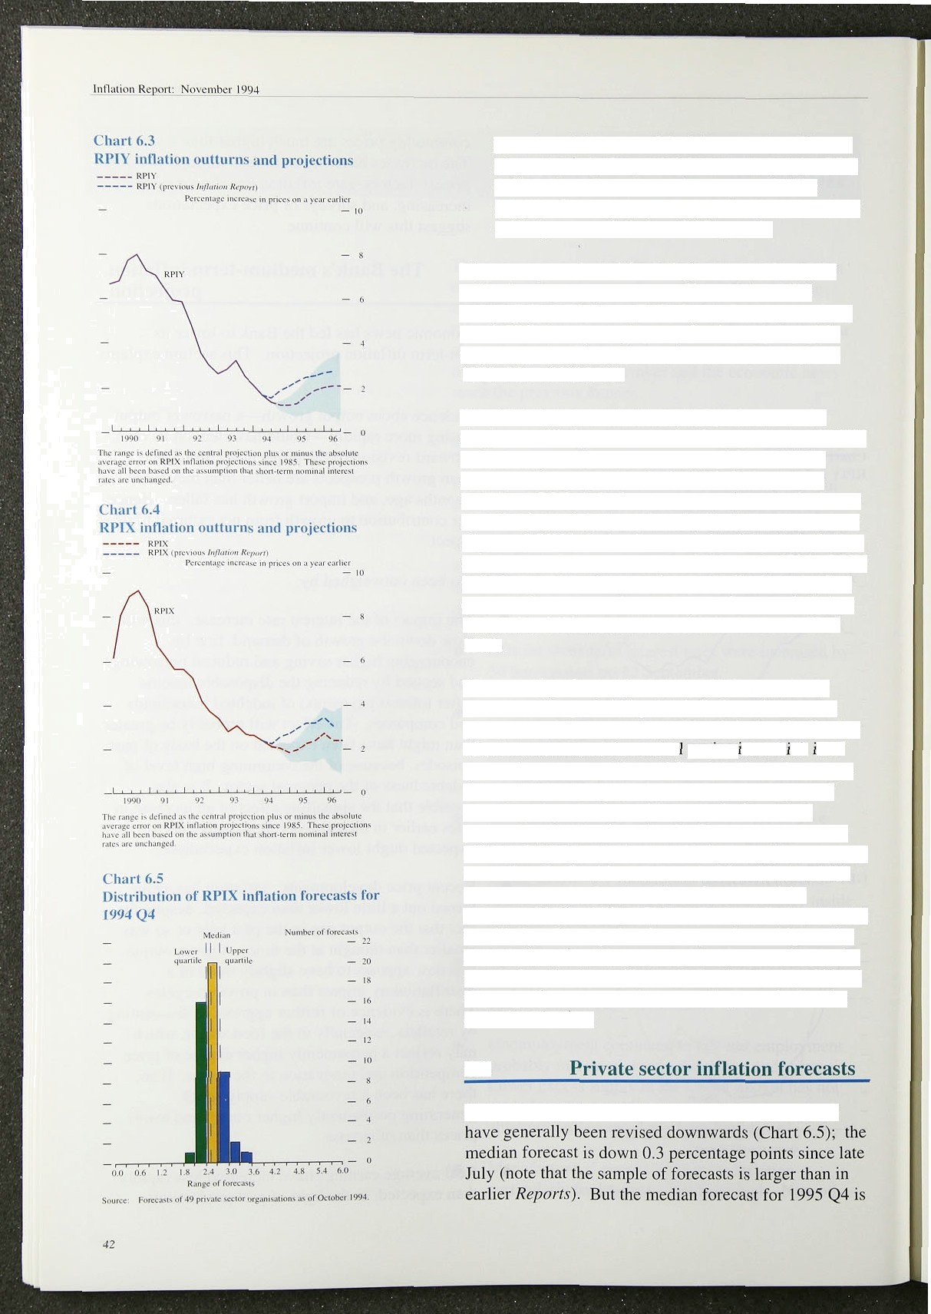growth and the state of the labour market. Hence, given past inflation, unit labour costs and the **GDP** deflator have been lower than expected. The growth of real disposable income and consumption is likely to remain below **GDP** growth.

It is not unprecedented for inflation to remain steady while the output gap narrows. Charts 6.1 and 6.2 compare the evolution of inflation and deviations from trend **GDP** (a very rough proxy for the output gap) in similar stages of the two most recent business cycles, 1979—55 and 1990-94.

Chart 6.3 show s the Bank’s central projecfio the single most likely outcome—for the annual rate of **RPIY** inflation over the next two years, and Chart 6.4 the corresponding projection for RPIX inflation. Both RPIY and RPIX inflation are now projected to be lower over the forecast horizon than they were in the previous *Report.* **RPIY** inflation is expected to fall a little further and then to edge up to just over 2% in early 1996. **RPIX** inflation—although increasing gradually from the fir.st quarter of next year—is now expected to remain below 39r, and to f‹ill back to about 2’/ % in the first half of 1996.

The central projection is only the single most likely outcome. The probability thai inflation will turn out precisely at that level is negligible. It is the distribution of outcomes around the centra project on wh ch s of greater importance. Charts 6.3 and 6.4 include a range around the central projections to show the degree of error in past projections. The range is the central projection plus or minus the absolute average error on RPIX inflation projections made since 1985. But it does not reflect the Bank’s assessment of the risks to which the current projection is subject. Because of the downward inflexibility of many prices, inflation is much less likely to be negative than, say, twice as high as the central projection. At present, the risks are more on the upside than the downside (see below). But the width of the range demonstrates the uncertainty attached to the central projection.

6.3

Projections of 1 2-month RPIX inflation for 1994 Q4



Giiart 66

. Distr1bupon of!RPiX.!nfia’non forecasts far

isss q4





 

 



’’’’’’’’’0.0:'j' R#’’’’I2.’’,’ ¿.8.’’,§%'.’’.’’3,0’.’”’J6’’%:’2’’:’’:“ 8 3%”..’60 ’’



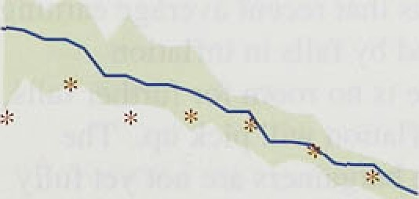









down oniy ,0.2 percentage points (Chart 6.6), despite

interest rate forecasts having been increased by around

.hglf a! percentage poi.nt. The Bank has tended to be. more optimistic: about inflation than the median .outside. forecaster. Charts 6.7.and .6.8 demonstrate this for exp:ectations about inflation in 1994 Q4 and 1995 Q4

,(fewer outside forecasters are reported in these charts than in Charts 6.5 and 6.6 in order to obtain a monthly instead of quarterly median).

.Chaff 6.9 shows that the inflation expectations impI.icit i:n gilt prices—which apply to the medium term, not the next two years—are very similar to those of three months ago, but peak at a slightly higher level. They

.had:risen prior to the base rate increase, which, in turn, helped to bring them do.wn again.

##### !6.4 The risks to the inflation outlook

It is important to consider the whole distribution of possible inflation outturns, not just the central

.projection. In present circumstances, the Bank’s economic judgment ft that this distribution is not symmetric. The risk of inflation being higher than. the

.central projection is greater than the probability of it

!being.lower. There is necessarily considerable uh/certainty ab:out what will happen to. external factors

,(eg ,commodity prices, .US monetary policy). But there ts a'1so .uncertainty about key economic relationships at whoiRe. Some of the .most important of those uncertainties are the following.

.There.is uncertainty about three aspects of pricing



 The,extent to which increases in input prices will be passed through to factory-gate prices. So far, favourable developments in unit labour costs have panly offset the impact of higher input prices, but it is uncertain how far producers have adjusted their pricing in response,to the increases seen this year.

 .Although producer output prices .have started to accelerate, they hiivg.riot done so by as much as

.firms’ reported. prieel exp:ectations would have led one to expect. This. may mean further increases are i :tfie pipqli*e.

Increased competi!tiofi i:n.the..retail sector has

.reduced retail:price inflation. relatixe.:to.producer



[nil' ikFp‹d: November 1904



I net ril›u lii›n ‹›l' R PI X inlIatii›ii tiirecasts mm



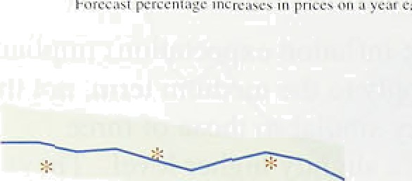

price inflation over the past year, to a greater extent than expected. This could reflect two factors, either: (i) a structural change in the sector, implying a benign supply shock to the economy with permanently lower retail margins; or (ii) a cyclical reduction in margins. If the second factor has been more important, then the risk to inflation is that the reduction in margins unwinds as the economy expands.

A fourth iTiajor uncertainty concerns the labour market. The outturn for nominal earnings depends upon the real wage targeted by wage bargainers and the inflation they expect. The current projection is based on two assumptions:

0 Real wages are a little more sensitive to the state of the labour market than they used to be.

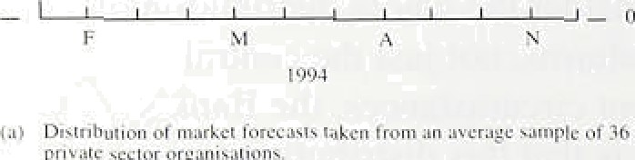G Inflation expectations over the horizon for wage bargains have fallen, and will remain low. at least in the short run.



I us plieit 1‘iiru **ard** intJatiriii **rates**

- *i› ix«iwr

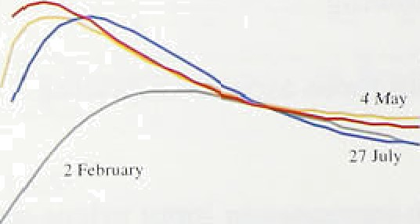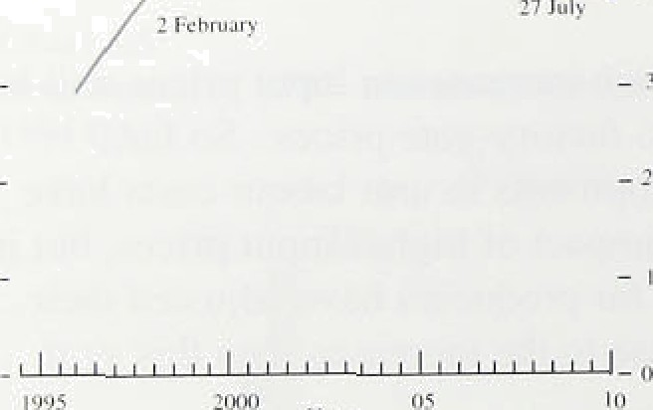

her *ciii

— ^

Neither assumption is certain. The ffrst is important because real unit labour costs have fallen sharply (see Chart 4.9). In the past, such a situation has tended to lead to higher wage inflation, as employees have attempted to restore their real earnings. The Bank’s projection allows fpr some increase in pre-tax real wages, but not as much as past behaviour would warrant. The second assumption is difficult to test directly because there are no measures of the price expectations which influence wage bargainers in practice. The upside risk is that recent average earnings growth has been moderated by falls in inflation expectations, but that there is no room for further falls, so earnings growth and inflation will pick up. The downside risk is that wage bargainers are not yet fully convinced that inflation will remain low over the next couple of years, but will become so. Pricing in the gilt markets shows that there is still room to improve the credibility of monetary policy. Anything which does so, inclii‹1ing low inflation outtums, may mean lower nominal wages—and hence inflation than in the central projection.

A fifth uncertainty arises from the behaviour of narrow money. Some acceleration was to be expected this year as people adjusted to the lower opponunity cost of holding money after the substantial reduction in

short-term interest rates between September 1992 and



Februñry 1994. There is no sign of M4 growth

.increasing to any noticeable extent. Nevertheless, M0 growth has proved a good leading indicator of retail inflation in the past, so the fact that it remains higher than expected—and outside its monitoring range—is cause for concern.

## Conclusions

Retail price inflation fell again over the past quarter. Underlying inflatio n, excluding indirect taxes, fell from l.79r at the time of the August *Rey‹›rt* to l.2% in September. The Clovernment’s measure of underlying inflation. which includes the effect of higher indirect taxes, fell from 2.4% to 2.09 over the same period, and has now been within the lower half of the 1%—49• target range each month since March.

Producer price inflation, however, has started to rise. Non-oil commodity prices are much higher ihan a year

‹igo, and the 12-month rate of increase of producer inyx/ pi’ices rose from 2.1 & at the time of the August *Report* to 5.6% in September. Producer *nutyut* price inflation rose from 2.19c to 2.4% over the same period.

Excluding those components most affected by changes in excise duties—food, drink, tobacco and petroleum— the increase in the 12-month inflation rate was a little less. But, even otl this definition, shorter-run measures of inflation have risen Sharply from I.4% to 3.6% between June and September. It is not clear that this yet fully reflects the ftse in intermediate goods prices. The balance of firms intending to raise their prices, as reported in the CBI Survey. has remained at a high level, and the latest Survey reported that more firms had been able to achieve price increases.

This difference between retail and producer price inflation reflects the nature of the recovery. Market conditions at home remain tight, whereas exports have grown strongly. The growth rate of real domestic demand has fallen each quarter this year. Consumption growth has clearly slowed atid, despite the strong financial position of the corporate sector, aggregate investment has not yet picked up to any significant extent. But export growth has been strong. manufacturing investment has risen and output growth has continued above trend.

The outlook for inflation remains favourable. Broad money growth continues at a moderate rate of around 5% with little sign of any increase. Narrow money has been growing at rates outside its monitoring range, but the impact of earlier interest rate reductions explains much of this. Nominal domestic demand growth has

.slowñ‹i from.aroun‹i 6% at the end of last year to around 5%. one of theselmorietaiy.developments suggests that

.a sharp rise in inflation is imminent. Retail price infation is .likely to remain low. The Bank’s central projection is that RPIX inflation will bottom out in the comi!n!g months, and will rise gradually over the next two years to aroi:nd 2'/2.&o, at the top of the lower half of the target range.

But the central projection is precisely that—the single most hikely outcome. There are many rlsks to that ou!teome, and. the Bank’s economic judgment is that they are not,. at present, symmetrically distributed around the central projection. It is not surprising that at very low rates of.inflation the risks should be more on the upside. But there is particular uncertainty about the durability of the recent fall in retail price inflation. The greatest uncertainty concerns the continuing difference between

.retail and producer price inflation. It is not clear how far price pressures will be passed down the production and retail chain. The compression of retail margins, seen through most of this year, might crime to a halt or even unwind. As output continues to grow above trend, it bec:omes more likely that.rises in the prices of intermediate goods will feed through to retail prices.

Hi!gher.Earnings growth than is built into the central

.projection would.make this more probable. It will be

.necessary ,to monitor these developments very carefully.

